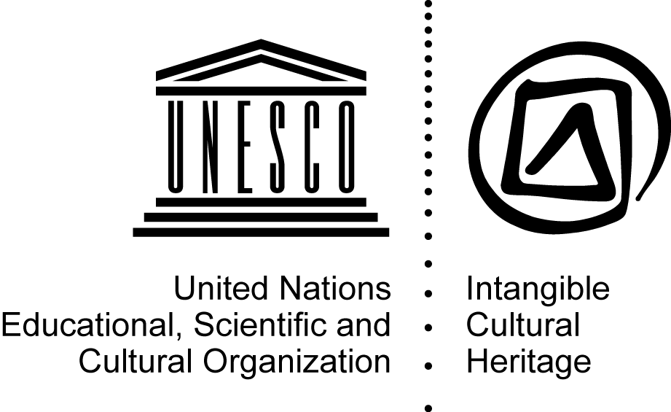
CONVENTION FOR THE SAFEGUARDING
OF THE INTANGIBLE CULTURAL HERITAGE
General Assembly of the States Parties to the Convention
for the Safeguarding of the Intangible Cultural Heritage
Third session
UNESCO Headquarters, Room II
22-24 June 2010
Item 10 of the provisional agenda:
Tenth anniversary of the adoption of the Convention for the Safeguarding of the Intangible Cultural Heritage by the General Conference of UNESCO
Decision required: paragraph 5

1. The Convention for the Safeguarding of the Intangible Cultural Heritage was adopted by the General Conference of the United Nations Educational, Scientific and Cultural Organization at its 32nd session on 17 October 2003. It entered into force on 20 April 2006, three months after the deposit with the Director-General of the thirtieth instrument of acceptance.
2. The Convention was swiftly and steadily ratified, showing the sustained interest of States and the international community in its principles and values and in safeguarding the intangible cultural heritage. A total of 52 States had ratified the Convention by the time of the first session of the General Assembly of States Parties to the Convention in June 2006. This number increased to 67 at the first extraordinary session of the General Assembly in November 2006, 98 in June 2008 at its second session, then 123 at this, its third session (June 2010).
3. Since the Convention entered into force, its General Assembly has adopted its Rules of Procedure, approved the operational directives for the implementation of the Convention and selected an emblem for the Convention. The Intergovernmental Committee for the Safeguarding of the Intangible Cultural Heritage, which has since met on seven occasions, has adopted and revised its Rules of Procedure, incorporated the 90 items proclaimed “Masterpieces of the Oral and Intangible Heritage of Humanity” in the Representative List of the Intangible Cultural Heritage of Humanity and inscribed 76 other items on that same list, 12 items on the List of Intangible Cultural Heritage in Need of Urgent Safeguarding and 3 items as programmes, projects and activities that best reflect the principles and objectives of the Convention. Furthermore, the Intergovernmental Committee has recommended to the General Assembly for accreditation 98 non-governmental organizations which may provide advisory services to the Committee and approved, through its Bureau, 20 international assistance requests including preparatory assistance requests for the Urgent Safeguarding List, and the programmes, projects and activities that best reflect the principles and objectives of the Convention.
4. In 2013, the Convention will celebrate its 10 years of existence. This tenth anniversary may be the occasion to conduct an initial assessment and identify the challenges, constraints and opportunities connected with the implementation of the Convention and to organize activities for raising awareness of the importance of the intangible cultural heritage and reflecting on the needs and challenges related to its safeguarding.
5. The General Assembly may wish to adopt the following resolution:

DRAFT RESOLUTION 3.GA 10
The General Assembly,
1. Having examined document ITH/10/3.GA/CONF.201/10,
2. Noting that in 2013, the Convention for the Safeguarding of the Intangible Cultural Heritage will celebrate its tenth anniversary,
3. Considering the rapid pace of ratification of the Convention and the great interest it raises with the international community,
4. Invites the countries that have not yet done so to ratify the Convention at their earliest convenience;
5. Decides that the tenth anniversary of the adoption of the Convention will be an occasion for the international community engaged in safeguarding the intangible cultural heritage to conduct an initial assessment and identify the main challenges, constraints and opportunities related to the implementation of the Convention for the Safeguarding of the Intangible Cultural Heritage;
6. Invites the Committee to consider, at its forthcoming sessions, ways of celebrating the tenth anniversary of the Convention;
7. Further invites the Committee to submit to it at its fourth session in June 2012 a programme and schedule for the celebration of the tenth anniversary of the Convention.

In four ordinary sessions (first session 1.COM, 18-19 November 2006, Algiers, Algeria; second session 2.COM, 3-7 September 2007, Tokyo, Japan; third session 3.COM, 4-8 November 2008, Istanbul, Turkey; fourth session 4.COM, 28 September to 2 October 2009, Abu Dhabi, United Arab Emirates) and in three extraordinary sessions (first extraordinary session 1.EXT.COM, 23-27 May 2007, Chengdu, China; second extraordinary session 2.EXT.COM, 18-22 February 2008, Sofia, Bulgaria; third extraordinary session 3.EXT.COM, 16 June 2008, UNESCO Headquarters, Paris, France).

