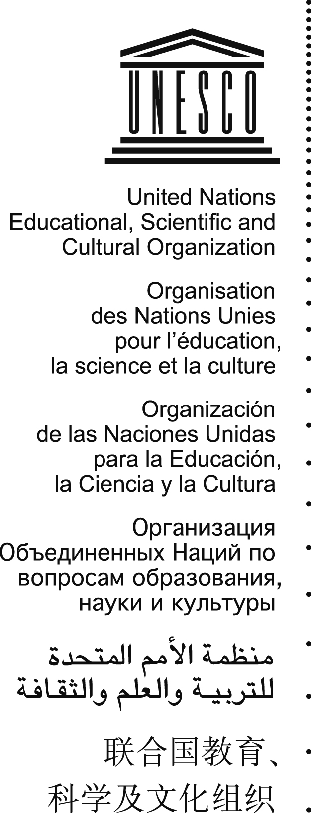
Address by Mr Francesco Bandarin,
UNESCO Assistant Director-General for Culture,
on the occasion of the opening of the third session of the
General Assembly of States Parties to the Convention
for the Safeguarding of the Intangible Cultural Heritage

UNESCO Headquarters, 22 June 2010

Excellencies, Ladies and Gentlemen,
I am truly pleased to address this Assembly on behalf of the Director-General, Ms Irina Bokova, who, as you know, unfortunately cannot be with us as she is required to take part in the eighth Summit of Heads of State of South-East Europe in Istanbul, which, moreover, is devoted this year to a theme closely connected to the intangible heritage: “Music as a metaphor of cultural dialogue in South-East Europe”. She will however join us for the closing of the Assembly’s session on Thursday evening, and she will address you on that occasion.
I have the honour of participating in the proceedings of this important Assembly only a few days after taking office as Assistant Director-General for Culture.
Once cannot fail to observe that the Convention has come a long way. In the last few years, and in particular in this past year, there has been much reflection and work accomplished. Conditions are ripe for the General Assembly to make the necessary decisions to accompany the implementation of the Convention which is still nascent, but which has already revealed its full potential.
There is also no denying that this Convention, indeed all the conventions overseen by the sector which I have the honour of directing, are a mainstay of UNESCO’s activities. This Convention has a specific importance, along with the other conventions, and in particular the 1972 World Heritage Convention and the 2005 Convention of the Protection and Promotion of the Diversity of Cultural Expressions, in providing a very solid response to the provisions of UNESCO’s Constitution – the spread of culture, mutual assistance, and the free exchange of ideas and knowledge “for the purposes of mutual understanding and a truer and more perfect knowledge of each other’s lives”.
But it must also be said that this Convention has a major importance in the light of contemporary challenges: the need to strengthen dialogue among cultures, to respect equal dignity, and the need to better integrate culture in order to attain the development goals.
The Convention for the Safeguarding of the Intangible Heritage carries within it all of these challenges: it is a concrete tool for dialogue and the promotion of cultural diversity; it is also a force for social cohesion, for the well-being and the development of societies at the economic, social, educational and even political levels.
This is certainly a strong element of UNESCO’s positioning within the United Nations system, which we must explore without delay, and which can, in very concrete terms, illustrate how our Organization can contribute to the system’s common goal.
As you know, a very special summit will take place in September this year in New York to review the Millennium Development Goals. This Organization has already positioned itself so as to facilitate the close association of culture with the Millennium Development Goals. This Convention, with the other UNESCO conventions, will be the stars of this strategy.
In the coming days, the Assembly must work on important matters, such as the review, already, of the Operational Directives. Let me reassure you: the World Heritage Convention, which will soon celebrate its 40th anniversary, is still reviewing its own Operational Guidelines and has done so continuously over the years. The Operational Directives are only a guide, an instruction manual for implementation, and it is no
t only normal, but also a good sign in my opinion, to adapt them as time goes by, to always stay in tune with the changing reality of implementation.
Other important issues are also on your agenda: the Committee elections, of course, which are always a highlight in the life of the conventions, but also the way in which you would like the resources of the Fund for the Safeguarding of the Intangible Cultural Heritage to be used, accreditation of non-governmental organizations, and the thorny, yet unavoidable issue of reinforcing the Secretariat’s human resources. I am aware, as is the Director-General, of the difficulties facing the Convention’s Secretariat, and rest assured that for our part we will make every possible effort to provide reinforcement as far as we are able.
There are issues which will drive proceedings over the next three days, but which, I am sure, will be discussed in a constructive spirit for the benefit of all, so as to enable this Convention to live up to its many promises.
I have noted that you will also be launching, already, a discussion on the celebration of the tenth anniversary of the Convention which is approaching. Anniversaries are always the right moment for reflection and stock-taking, and I am sure that this one will be no different.
In conclusion, Mr Chairperson, I would also like to thank you for the years of work that you have given to this Convention, which have been very intensive and productive. I am certain that thanks to your skill and competence, many themes and problems have been addressed, discussed, dealt with and approved. I therefore believe that I speak on behalf of everyone in thanking you for your work throughout these years. And lastly, ladies and gentlemen, I extend my most sincere wishes to you for the success of this General Assembly.

