CERN-LHCC-2005-025
LHCC-I-015

FP420 : An R&D Proposal to Investigate the Feasibility of Installing Proton Tagging Detectors in the 420m Region at LHC

M. G. Albrow¹, T. Anthonis², M. Arneodo³, R. Barlow^{2,4}, W. Beaumont⁵, A. Brandt⁶, P. Bussey⁷, C. Buttar⁷, M. Capua⁸, J. E. Cole⁹, B. E. Cox^{2,*}, C. DaVià¹⁰, A. DeRoeck^{11,*}, E. A. De Wolf⁵, J. R. Forshaw², J. Freeman¹, P. Grafstrom^{11,+}, J. Gronberg¹², M. Grothe¹³ , J. Hasi¹⁰, G. P. Heath⁹, V. Hedberg^{14,+}, B. W. Kennedy¹⁵, C. Kenney¹⁶, V. A. Khoze¹⁷, H. Kowalski¹⁸, J. Lamsa¹⁹, D. Lange¹², V. Lemaitre²⁰, F. K. Loebinger², A. Mastroberardino⁸, O. Militaru²⁰, D. M. Newbold^{9,15}, R. Orava¹⁹, V. O’Shea⁷, K. Osterberg¹⁹, S. Parker²¹, P. Petroff²², J. Pinfold²³, K. Piotrzkowski²⁰, M. Rijssenbeek²⁴, J. Rohlf²⁵, L. Rurua⁵, M. Ruspa³, M. G. Ryskin¹⁷, D. H. Saxon⁷, P. Schlein²⁶, G. Snow²⁷, A. Sobol²⁷, A. Solano¹³, W. J. Stirling¹⁷, M. Tasevsky²⁸, E. Tassi⁸, P. Van Mechelen⁵, S. J. Watts¹⁰, T. Wengler², S. White²⁹, D. Wright¹²

- FNAL
- The University of Manchester
- University of Eastern Piedmont, Novara and INFN-Turin
- The Cockcroft Institute
- University of Antwerpen
- University of Texas at Arlington
- The University of Glasgow
- University of Calabria and INFN-Cosenza
- Bristol University
- Brunel University
- CERN
- Lawrence Livermore National Laboratory
- University of Turin and INFN-Turin
- University of Lund
- Rutherford Appleton Laboratory
- Molecular Biology Consortium
- Institute for Particle Physics Phenomenology, Durham University
- DESY
- Helsinki Institute of Physics and University of Helsinki
- UC Louvain
- University of Hawaii
- LAL Orsay
- University of Alberta
- Stony Brook University
- Boston University
- UCLA
- University of Nebraska
- Institute of Physics, Academy of Sciences of the Czech Republic
- Brookhaven National Laboratory

+ ATLAS contacts for forward detectors

* Correspondence should be addressed to

Brian.Cox@manchester.ac.uk
Albert.deroeck@cern.ch

1. Executive Summary

The physics potential of forward proton tagging in the 420m region at the LHC has only been fully appreciated within the last few years. By detecting protons that have lost less than 1% of their longitudinal momentum, a rich QCD, electroweak, Higgs and BSM program becomes accessible, with the potential to make measurements which are unique at LHC, and difficult even at a future linear collider.

By tagging both outgoing protons at 420m in the process pp → p + X + p, the LHC is effectively turned into a glue-glue collider. Initially, this will open up a rich, high-rate diffractive and QCD physics menu, allowing the study of the off-diagonal un-integrated gluon densities of the proton, rapidity gap survival (and therefore underlying event), and providing a source of almost pure gluon jets. In the few-fb⁻¹ luminosity range, a new field of high-energy photon physics opens up, giving access to precision studies of the quartic gauge couplings, anomalous W or Z pair production and, at higher luminosities, supersymmetric particle pair production in an extremely clean environment. As the delivered luminosity reaches 10’s of fb⁻¹, the double-tagged ‘central exclusive’ production process becomes a tool to search for new physics, delivering signal to background ratios greater than unity for Standard Model (SM) Higgs production, more than an order of magnitude larger for certain supersymmetric (MSSM) scenarios. It can provide a clear determination of the Higgs quantum numbers and excellent mass resolution, which may be necessary to resolve a nearly degenerate Higgs sector. It also offers a unique probe (at least until a linear collider) of the CP structure of the Higgs sector, through azimuthal asymmetry measurements of the tagged protons or detailed analysis of the missing mass lineshape. In addition to Higgs physics, 420m proton tagging provides an opportunity to investigate the entire strong interaction sector of physics within and beyond the Standard Model, from the production of heavy hadron resonances to gluinonia and radions. In pA collisions, the precision study of ultra-peripheral heavy ion collisions will be possible.

The 15m drift spaces around 420m from the ATLAS and CMS interaction points offer a physics opportunity that is not exploited in the current LHC physics programme. Protons that lose between 10⁻³ and 10⁻² of their initial momenta emerge from the beams in these regions, which we propose to instrument in the FP420 project. In doing so, we will access a broad range of low-x hard QCD processes, and the central mass range of 115 GeV and upwards which is required for Higgs and discovery physics. This region is at present enclosed in a 'connection cryostat' which maintains a series of superconducting bus-bars, and the beam pipes themselves, at a temperature of 1.7K. A prerequisite for the FP420 project is to assess the feasibility of replacing the 420m interconnection cryostat to facilitate access to the beam pipes and therefore allow proton tagging detectors to be installed. Our intention is to initiate an R&D project based at CERN in collaboration with the UK Cockcroft Institute for Accelerator Science, with the AT/CRI group, the TS/LEA group and with the institutes named on this proposal to provide a feasibility study and conceptual design for the instrumentation of the 420m region. The first opportunity to install such detectors would be the planned LHC shutdown in autumn 2008.
Such a physics program cannot be carried out with short runs at high-beta optics, (and consequently low luminosity), but will need the high statistics provided by standard, high luminosity running.

The UK groups on this proposal have been awarded 100k pounds of ‘seed-corn’ money in FY 05 / 06 to support initial design studies.

We would like to ask the LHCC to take note of this LOI and its physics goals, and endorse the proposed R&D program.

2. The Physics Case for Forward Proton Tagging at 420m

The 420m detectors would cover the region of fractional proton momentum loss 0.002 < ξ < 0.02, giving access to central systems in the mass range 30 < M < 200 GeV. This complements and extends the reach of the proposed 220m detectors at ATLAS and CMS / TOTEM, which have no acceptance for central systems below 200 GeV with double proton tags in normal high-luminosity LHC running. For the high-precision QCD and diffractive program, relatively high luminosity and low ξ are the primary requirements. Similarly for the γγ and new physics programs, acceptance for relatively low central masses in nominal, high-luminosity running is required.

The potential of forward proton tagging to increase the discovery potential of the LHC rests on the unique properties of the central exclusive production process. By central exclusive, we refer to the process pp → p ⊕ φ ⊕ p, where ⊕ denotes the absence of hadronic activity ('gap') between the outgoing protons and the decay products of the central system φ. There are three primary reasons why this process is attractive. Firstly, if the outgoing protons remain intact and scatter through small angles, then, under some general assumptions, the central system φ is produced in the J_{z}=0, C and P even state. An absolute determination of the quantum numbers of any produced resonance is possible by measurements of the correlations between outgoing proton momenta. Secondly, the mass of the central system can be determined very accurately from a measurement of the transverse and longitudinal momentum components of the outgoing protons alone (section 3). This means an accurate determination of the mass irrespective of the decay mode of the centrally produced particle. Thirdly, the process delivers excellent signal to background ratios, due to the combination of the J_{z}=0 selection rules, the mass resolution, and the cleanness of the event in the central detectors. An additional attractive property of central exclusive production is its sensitivity to CP violating effects in the couplings of the object φ to gluons.

2.1 QCD and Diffractive Physics

Proton-proton interactions with large rapidity gaps are a rich source of information about the fundamental properties of QCD. The addition of detectors at 420 m will extend the ξ acceptance of the roman pot detectors installed at 220 m by an order of magnitude to 0.002 for nominal LHC luminosity optics. Access to such low ξ values in pp collisions is unprecedented, significantly better than that achievable at the Tevatron, and overlapping with the HERA diffractive DIS range. This will allow precise, high statistics studies of, for example, the gluon content of the proton at low-x and gap survival probabilities in the HERA kinematic range, which in turn will provide valuable insight into the contribution of multi-parton interactions to the underlying event. The latter will be very important for the whole LHC physics program. The low ξ reach of the 420m detectors will also allow the diffractive structure functions of the proton to be probed at low values of β and high values of Q² beyond the HERA range. Single diffractive production of W, Z and ϒ will be interesting in their own right, probing different kinematic regions of the diffractive structure functions, as well as being valuable processes for the detector calibration.

The cross section for the central exclusive production of di-jets is predicted to be ~ 1 nb for 2 jets with E_{T} > 20 GeV, |η| < 1 and invariant mass M_{JJ} > 50 GeV, falling to ~ 0.5 pb for E_{T} > 50 GeV, M_{JJ} > 200 GeV. The high rate will allow for a precise determination of the off-diagonal un-integrated gluon densities of the proton and the gap survival probability at 14 TeV. Whilst of interest in its own right, this measurement will allow the uncertainties in the predictions for the central exclusive production cross sections of Higgs bosons and other exotic particles to be reduced to the 1% level, which will in turn allow the observed rates for the production of exotic objects to be compared with theoretical expectations, and any anomalies investigated. The off-diagonal un-integrated gluon densities themselves will be measured in a region that may be sensitive to saturation or colour glass condensate effects.

The processes pp → p + γγ + p is an important calibration process, as well as being interesting in its own right. The cross section for exclusive di-photon production is approximately 30 fb (6fb) for E_{T} values of the photons larger than 10 (15) GeV and with both photons in the central region, |η| < 2. This process can only be studied with luminosities of order 10³³ cm⁻² s⁻¹.

With the collection of high statistics samples of double-tagged events, high-precision measurements of the diffractive t-distribution up to around 4 GeV², a much larger region than feasible at HERA, will be possible, in both single diffractive and central exclusive events. Several possibilities will open up, including the study of saturation effects, parton-parton correlations in the proton and a sensitive probe of screening effects, including an independent measurement of the gap survival factor.

2.2 Discovery Physics Using Central Exclusive Production

The ‘benchmark’ central exclusive production process for new physics searches is Standard Model (SM) Higgs production. The cross section for pp → p ⊕ H ⊕ p was calculated in [1,2] to be 3 fb for M_{H} = 120 GeV, falling to ~ 1 fb at M_{H} = 200 GeV. The simplest channel to observe the SM Higgs from an experimental perspective is the WW decay channel. For M_{H} = 140 GeV, we expect 19 exclusive H → WW events to have double proton tags using both 220m and 420m detectors (none using 220m detectors alone), for an LHC luminosity of 30 fb⁻¹. This rises to 25 at 160 GeV. Of these, approximately 25% will be taken by the standard ATLAS and CMS level 1 leptonic triggers, although we expect that with further optimisation of the trigger thresholds this efficiency should rise to close to 50% [2]. In the gold plated semi-leptonic channels, the signal to background ratio will be in excess of unity, and observation of SM Higgs in this channel will cleanly establish its quantum numbers with 30 fb⁻¹ of delivered luminosity.

More challenging from a trigger perspective is the b-jet decay channel. That this channel is possible to observe at all is a consequence of the J_{z}=0 selection rules for central exclusive production [3], which heavily suppresses exclusive b-jet production; in conventional channels this signal is swamped by the copious QCD background. For M_{H} = 120 GeV, we expect 60 exclusive H → bb events to have double proton tags using both 220m and 420m detectors. A recent study [4] found that, after taking into account losses due to b-tagging efficiencies and kinematic cuts to reduce backgrounds, and the likely achievable mass resolution of the proton tagging detectors, 11 signal events remain with a signal to background ratio of order unity for a luminosity of 30 fb⁻¹. We discuss triggering in more detail in section 4.

The b-jet channel becomes extremely important in the so-called ‘intense coupling regime’ of the MSSM. This is a region of MSSM parameter space in which the couplings of the Higgs to the electroweak gauge bosons are strongly suppressed, making discovery challenging at the LHC by conventional means [5]. The rates for central exclusive production of the two scalar MSSM Higgs bosons are enhanced by an order of magnitude in these models, however. We expect close to 1000 exclusively produced double-tagged h and H bosons with 220m and 420m detectors in 30 fb⁻¹ of delivered luminosity, for M_{h,H} ~ 125 GeV and tan β = 50 [6]. Under the same assumptions as for the SM Higgs, approximately 100 would survive the experimental cuts, with a signal to background ratio of order 10. It is also worth noting that the pseudo-scalar Higgs (A) is practically not produced in the central exclusive channel, allowing for a clean separation of the scalar Higgs bosons which is impossible in conventional channels. For such regions of the MSSM, central exclusive production is likely to be the discovery channel.

There are extensions to the MSSM in which central exclusive production becomes in all likelihood the only method at the LHC of isolating the underlying physics. One example, recently studied by Ellis et al. [7], is the case where there are non-vanishing CP phases in the gaugino masses and squark couplings. In such models, the neutral Higgs bosons are naturally nearly degenerate for large values of tan β and charged Higgs masses around 150 GeV. The authors conclude that observing the missing mass spectrum using forward proton tagging may well be the only way to explore such a Higgs sector at the LHC. It was also noted in [8] that explicit CP-violation in the Higgs sector can show up as a sizeable asymmetry in the azimuthal distributions of the tagged protons – again a measurement which is unique at the LHC.

As well as the specific models discussed above, central exclusive production is an extremely attractive way of searching for any new particles that couple strongly to glue. An example studied in [1] is the scenario in which the gluino is the lightest supersymmetric particle. In such models, there should exist a spectrum of gluino – gluino bound states which can be produced in the central exclusive channel.

During the recent HERA – LHC workshop, there was a large amount of work carried out on assessing the uncertainties in the central exclusive cross sections quoted above. The consensus view is that the primary uncertainty comes from the errors on the knowledge of the off-diagonal un-integrated gluon distributions of the proton (for example see [9]), leading to an uncertainty of a factor of 2 – 3 in the rate. Both the CDF and D0 Collaborations are in the process of searching for related central exclusive production signals at the Tevatron, including di-jet and χ_{C} production. At the time of writing, all preliminary results are compatible with the expectations of [1] (for a recent review, see [10] and references therein).

2.3 High Energy Photon Physics with FP420

As well as the new physics discovery potential delivered by the central exclusive process, the 420m region makes possible a unique and exciting program of high-energy photon interactions physics at the LHC [11]. Using events when two forward protons are detected, photon-photon interactions can be selected at energies well above the electroweak scale. The two-photon production of W pairs will allow studies of the quartic gauge couplings γγWW. The production cross section is 110 fb with average M_{γγ} > 300 GeV, leading to approximately 1000 events in the semi and fully leptonic decay channels in 30 fb⁻¹. This would deliver sensitivity to anomalous quartic couplings a factor of 10,000 times better than the current LEP2 limits. There is no other way at the LHC to approach this level of sensitivity. There is similarly high sensitivity to the anomalous production of Z pairs in the process γγ→ZZ. The photoproduction of supersymmetric charged pairs, such as charginos and sleptons, or indeed any central systems which have large couplings to photons, is also a possibility [12].
Tagging a single proton at 420m opens up a rich field of high-energy photon-proton interactions at the LHC. High-rate processes of interest include W boson production at high transverse momentum and top pair production via photon-gluon fusion.

Photon interactions are enhanced in heavy ion collisions thanks to the high ion charge, and studies of such ultra-peripheral collisions have been proposed [13]. Tagging of the forward protons in pA collisions would allow for a diffractive photoproduction program in a kinematic regime far beyond that available at HERA. Unique measurements of nuclear diffraction dissociation of A on a proton target can also be made. In addition, because FP420 has acceptance for proton transverse momentum losses in the per-mille range, tagging photoproduction in light ion-ion collisions becomes possible. This opens up the possibility of studying low x phenomena, by measuring diffractive photoproduction of heavy vector mesons. As an example, the cross-section for elastic photoproduction of upsilon is ~ 400 pb for pp and 1 μb for Ca-Ca collisions.

3. Experimental Acceptance, Resolution and Alignment

The acceptance of the combination of 220m and 420m detectors as a function of the mass of the centrally produced system at the CMS interaction region is shown in figure 1. The curves were obtained by the Helsinki group using the ExHuME Monte Carlo [14], which is a direct implementation of the calculations of [1], and a parameterisation of the MAD X LHC beam simulation program with optics version 6.2. An independent parameterisation developed by the UK FP420 group for the ATLAS interaction point gives similar results.
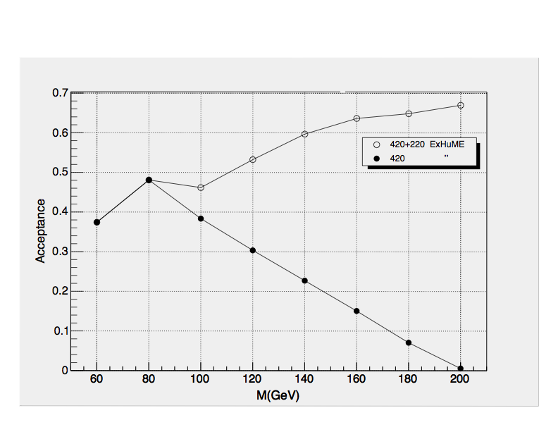

Figure 1. The acceptance of the 420m and 220m detectors as a function of the mass of the centrally produced system M, for luminosities below 5 x 10³³ cm⁻² s⁻¹. The acceptance will be lower in the high mass region (above ~ 130 GeV) for luminosities above 5 x 10³³ cm⁻² s⁻¹ when the 180m collimators are at 10σ.

For a 140 GeV central system, a missing mass resolution of ~ 1% will be achievable for both protons detected at 420m, deteriorating to 6% for events in which one proton is tagged at 220m [15]. There is no acceptance for masses below 200 GeV using 220m detectors alone. These figures depend on accurate alignment of the 420m detectors relative to the beam. From the experience of FP420 groups at HERA and the Tevatron, the best way of achieving accurate alignment is to use a high-rate physics process that produces a central system of known mass that can be associated with a proton track in the detector. Two-photon exclusive production of the lepton pairs is one such process. The cross section for the production of e⁺e⁻ pairs with p_{T} > 3 GeV is 3 pb. Of these, approximately 70% will have 1 proton tag in the 420m detectors. These events can be triggered in single interaction bunch crossings using the rapidity gap veto as detailed in section 4. We estimate that such events will allow an energy calibration of the detectors with a resolution of 3 x 10⁻⁴. Di-muon pair production can also be used, doubling the statistics. A potentially even better calibration process is the photoproduction of upsilon, since the invariant mass of the central system is fixed. The cross section for upsilon production, with subsequent decay to e⁺e⁻ pairs, is 10 pb.

4. Level 1 Triggering

A key challenge for the FP420 project is level 1 triggering. The 420m detectors are too far away from the interaction point to be included in the level 1 trigger systems of ATLAS or CMS without increasing the level 1 trigger latency. It is therefore necessary to save the interesting physics at level 1 using the central detectors, the forward detectors at 3< η < 6.8 (T1, T2, CASTOR in CMS/TOTEM and LUCID in Atlas), or the TOTEM or ATLAS Roman Pots at 220 m, if available. As we discussed in section 2, central systems that contain high-p_{T} leptons, such as H -> WW, are not a problem. The challenge arises in the case of low-mass states, such as the Standard Model Higgs boson, decaying into jets. Such states generate comparatively low E_{T} jet products, while triggers at LHC are generally designed for large E_{T} events.

We consider here perhaps the most challenging case, that of a low-mass (120 GeV) Standard Model Higgs boson, decaying in the b-jet channel. Here, the jets have transverse energies of at most 60 GeV. In order to retain a reasonable fraction of the signal, an E_{T} threshold as low as 40 GeV will be necessary. At 2 x 10³³ cm⁻² s⁻¹, for an E_{T} cut-off of 40 GeV per jet, the rate from standard QCD processes for central jets |η| < 2.5 is approximately 50 kHz, i.e. a factor 50 above the L1 jet rate of order 1 kHz currently assumed at CMS and ATLAS.

The following strategy to reduce the rate has been investigated [16,17]:

1) Selection on central detector quantities: requiring that essentially all the E_{T} be concentrated in the two jets gives a rate reduction of approximately a factor two, without affecting the signal efficiency.

2) Using, in conjunction with 1), the TOTEM forward detectors T1, T2 or Lucid at ATLAS as vetoes to impose the presence of large forward rapidity gaps suppresses the QCD background by several orders of magnitude with very high signal efficiency (>90%). However, it becomes ineffective as soon as there are pile-up events.

3) Using, in conjunction with 1), the TOTEM Roman Pots at 220 m (or the ATLAS luminosity system Roman Pots) gives excellent suppression of QCD background, by more than two orders of magnitude. Here as well the rejection power goes down at higher luminosities because of pile-up, although not as quickly as in the case of the rapidity gap veto with the forward detectors in 2).
A rate of a few kHz is achievable at 2 x 10³³ cm⁻² s⁻¹, which is compatible with the bandwidth requirements. The signal efficiency (Exhume) for an E_{T} threshold of 40 GeV is of the order 25% using this technique. In about 15% of the signal events, a proton is also seen in the Roman pots at 420 m on the side opposite from the 220 m pots that triggered the event.

4) An alternative trigger strategy may be to exploit the relatively muon-rich final state from b-decays. We estimate that up to ~10% of the signal events could be saved using this technique. Further investigations are underway at the time of writing.

Selecting a window for the invariant mass, M, of the diffractively produced system could further reduce the rate, by a factor ~5 for 110 < M < 140 GeV. This does not, however, take into account the resolution (~40%) for M achievable in the level 1 trigger.

Including detectors at 420 m in the level 1 trigger might be possible at lower luminosities and at a cost of increased level 1 deadtime, by way of a special, long latency running mode. This option is currently under investigation.

In summary, level 1 triggering is not a problem as long as there is no pile-up. For a 25 ns bunch structure, it is possible to collect ~ 6 fb⁻¹ of clean (no pile-up) events within 3 years of LHC running. This is enough to detect signals with central exclusive cross sections in the 50 fb range. An example would be the high tan β MSSM scenario discussed in section 2. At higher luminosities, up to ~ 2 x 10³³ cm⁻² s⁻¹, events in which 1 proton is detected at 220m can be saved. If the Roman Pot detectors at 420 m could be used, requiring that a proton be seen on both sides would yield a signal efficiency of the order of 15% and a rate reduction, at a luminosity of 10³⁴ cm⁻² s⁻¹ of ~35, to ~7 kHz. We expect no trigger problems for final states containing high-p_{T} leptons, such as the WW decay modes of the Standard Model Higgs boson.

5. Design and Installation of Proton Tagging Detectors in the 420m Region

5.1 Modifications to the 420m Region

The start-up LHC design has a 15m-long ‘connection cryostat’ at 420m which connects the superconducting arcs of the accelerator with the warmer interaction regions (see figure 2). This cryostat provides continuity not only of the beams, but also of the insulation vacuum, electrical power, cryogenic circuits and thermal and radiation shielding of the accelerator. Obviously, this continuity of the beamline and its services must be maintained in designing detectors for this region.

CERN's accelerator division has suggested two possible ways to achieve accelerator continuity while allowing addition of detectors at 420m. The key feature of the first proposal is a modification of the existing connection cryostat which would allow for insertion of detectors; this solution would minimise the modifications necessary to the accelerator, but it would require the FP420 detectors to work at liquid-Helium temperatures, and access to the detectors would require a warm-up of this section of the accelerator - foreseen to be at least a one-week procedure - followed by a similarly long process to cool down again after access.

The second proposal calls for eliminating the connection cryostat entirely, and replacing it with warm beam pipes surrounded by cold-warm transitions, and the addition of a new 'mini-cryostat' to maintain the continuity of the cryogenic and electrical lines. The detectors would be located on the warm beam pipe and would therefore operate near room temperature. This proposal will require more study and design work than the first proposal - in particular the design of the new mini-cryostat must start from scratch - but it is at present considered preferable from both the detector and accelerator points of view because it would make the detector more straightforward to design and operate, would greatly simplify access, and would eliminate the danger to superconducting accelerator components which may be posed by housing a heat-producing detector within them. Therefore we propose to thoroughly investigate this proposal as baseline, keeping the first proposal in mind as a backup.

A more detailed description of the proposed modifications to the 420m region, and an outline job specification for the UK engineering post to be based at CERN, can be found in the letter in appendix 1.

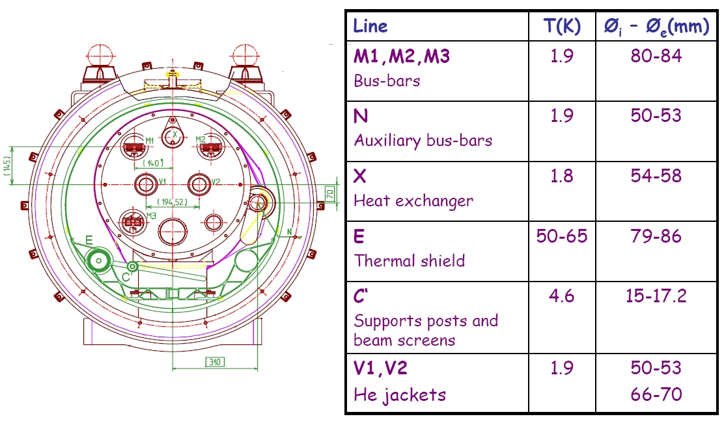

Figure 2. Schematic drawing of the present 420m connection cryostat. Protons from central elastic production can be detected by positioning suitable detectors between the beam pipes.

5.2 Detector Design

In order to achieve the missing mass resolutions quoted in section 3, we need to measure the displacement of protons from the closed orbit to a precision of 10 μm or better. The angles of the proton tracks must also be measured, and as long a lever arm as possible is therefore required. Protons that lose a small fraction of their longitudinal momentum emerge between the two beam pipes shown in figure 2. There is a spacing of 194 mm between the beam pipes. For injection, the active areas of the detectors must be kept ~ 20 – 30 mm away from the beams. When the beams are stable, they must be moved to within ~ 3 mm of the beams, depending on background conditions. The usual solution for getting detectors close to beams is to use ‘Roman Pot’ detectors, as will be used at 220m for TOTEM and for the ATLAS luminosity system. Given the space limitations at 420m, however, this conventional design is impractical, and a new solution must be found. The FP420 groups are investigating several possible designs for detector housings, including the ‘Microstation’ concept first developed for the LHC environment by the Helsinki group, the ‘Hamburg Pipe’ used for tagging outgoing electrons in photoproduction at HERA for many years, and a pivot design pioneered at Fermilab, which incorporates precision beam halo detectors which can be used in conjunction with beam position monitors to measure the position of the detectors relative to the proton beam.

It is important that the re-design of the cryostat at 420m and the detector mechanics studies are done as part of a common effort and in continuous consultation with the LHC machine group, to insure that the FP420 programme will not form a risk to or hinder in any way nominal LHC operation.

5.3 3D Silicon Technology

The leading contender for the detector technology choice is 3D edgeless silicon.
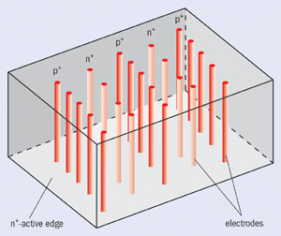
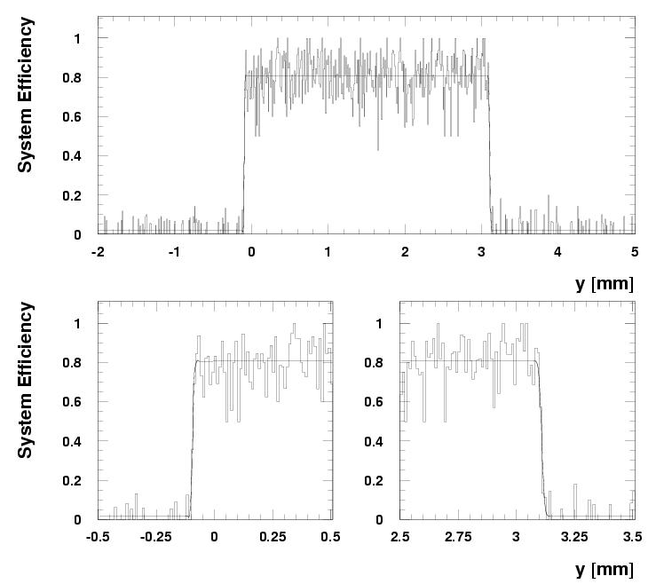
3D detectors are a new generation of semiconductor devices [18][19][20]. Using micro-machining techniques, electrodes penetrate the entire thickness of the detector perpendicular to the surface. This results in smaller collection distances, very fast signals and substantially improved radiation tolerance. Figure 3 (left) sketches the main features of this novel detector design. In addition, similar micro-machining techniques allow one to produce “active edges” where the amount of dead silicon at the edge of the detector is greatly reduced (Figure 3 right).

Figure 3. left. Sketch of a pure 3D detector where the p⁺ and n⁺ electrodes are processed inside the silicon bulk. The edges are trench electrodes (active edges) and surround the sides of the 3D device making the active volume sensitive to a few microns from the physical edge as measured with the SPS particle beam (right).

The response of 3D detectors was measured at the CERN SPS X5, in the TOTEM extraction line in 2003 [21]. The detector was sensitive to within 4μm of the edge. Radiation hardness tests have been performed using a fast 0.25 micron CMOS chip and showed that the signal is reduced by 20% after a proton fluence of 1x10¹⁵ cm⁻².

The FP420 physics program requires that the detector-electronics system contributes to the trigger information, at least at level 2, to provide accurate coordinates of triggered leading proton tracks. Pixel readout will be used because it provides unambiguous x/y information which substantially improves track reconstruction, reduces the number of planes, and improves the overall radiation hardness of the system. Moreover, suitable readout chips, with storage times above 5 microseconds, have been developed for ALICE, ATLAS, and CMS.

The electronic systems that need to be implemented at 420m include the sensor and front-end electronics, associated readout electronics, electronics for timing generation, electronics for fast coincidence processing and trigger generation and control room and service electronics. Several detector stations are foreseen within each connection cryostat. In order to guarantee robust tracking and trigger efficiency, several detector planes are foreseen in each station. 3D detectors are presently being fabricated to match the ATLAS pixel readout electronics chip. Lab tests with radioactive sources and test pulses will be performed in Autumn 2005. Test beams are planned in 2006. Planar/3D detectors, which combine traditional planar technology and 3D edge, will be used in the TOTEM experiment. They are less radiation tolerant than pure 3D but have the same edgeless performances. Since the radiation levels at 420 m are expected to be less than at 220m this should not be an issue. Planar-3D could be used in the initial phase if 3D pixel technology would require further development to fulfil the FP420 requirements, or in general as a backup solution.

The use of monocrystalline diamond pixel detectors is also being considered, and they may be an attractive alternative if beam tests and radiation hardness studies are successful.

Summary

We propose to perform a feasibility and R&D study on the option to equip the central detectors at the LHC with additional forward detectors at 420m from the interaction point. The study will include:

- A study of the cryostat re-engineering and costing, to allow for near - room temperature detectors. The UK can provide this engineer, who will need to work in close contact with the CERN AT/CRI and TS/LEA groups.
- A study of the detector mechanics in close contact with the engineer above.
- R&D on the detectors, with the leading candidate at present being 3D edgeless silicon.
- Detailed acceptance and resolution studies for the physics processes of interest, in close collaboration with the machine group for the proton tracking, beam optics, beam parameters and uncertainties.
- Detailed studies of the trigger capabilities when these detectors are combined with ATLAS and CMS and the feasibility of this measurement as function of the expected increasing luminosity of the LHC with time.
- An investigation into the feasibility of running the 420m detectors at luminosities up to 10³⁴ cm⁻² s⁻¹, which would open up increasingly exciting discovery potential and high precision measurements of exotic particle masses and properties.

The aim is to perform the initial design studies such that, when successful, technical proposals for extending the general purpose experiments with 420m detectors could be discussed within the experiments, and if accepted, submitted to the LHCC by the end of 2006. This feasibility and R&D effort is an open collaboration for interested participants.

We would like to ask the LHCC to take note of this LOI and its physics goals, and endorse the proposed R&D program.

References

[1] V. A. Khoze, A. D. Martin and M. G. Ryskin, Eur.Phys.J. C 23 (2002) 311-327.
[2] B. E. Cox et al., hep-ph/0505220.
[3] V. A. Khoze, A. D. Martin and M. G. Ryskin, Eur. Phys. J. C 19 (2001) 477-483, Erratum-ibid. (2001) C 20 599.
[4] A. De Roeck et al., Eur.Phys.J. C 25 (2002) 391-403.
[5] E. Boos, A. Djouadi and A. Nikitenko, Phys. Lett. B 578 (2004) 384-393.
[6] A. B. Kaidalov, V. A. Khoze, A. D. Martin and M. G. Ryskin, Eur. Phys. J. C 33 (2004) 261.
[7] J. R. Ellis, J. S. Lee and A. Pilaftsis, Phys. Rev. D 71 (2005) 075007.
[8] V. A. Khoze, A. D. Martin and M. G. Ryskin, Eur. Phys. J. C 34 (2004) 327.
[9] J. R. Forshaw, talks at the HERA LHC workshop, January 2005, http://agenda.cern.ch/askArchive.php?base=agenda&categ=a045699&id=a045699s5t5/transparencies
[10] B. E. Cox, AIP Conf. Proc. 753 (2005) 103-111, hep-ph/0409144.
[11] K. Piotrzkowski, Phys. Rev. D 63 (2001) 071502.
[12] K.Piotrzkowski, Proceedings of ‘Electromagnetic probes of fundamental physics’,171-181, Erice 2001, hep-ex/0201027.
[13] G. Baur et al., Proceedings of ‘Electromagnetic probes of fundamental physics’, 235-241, Erice 2001, hep-ex/0201034.
[14] J. Monk and A. Pilkington, hep-ph/0502077.
[15] T. Maeki, Master's Thesis, "Exclusive production of Higgs boson at the LHC collider: Higgs mass measurement via leading proton measurement”, Helsinki University of Technology (2003).
[16] Studies done in the framework of the CMS/TOTEM LOI for diffraction; to appear
M.Grothe, talk at the HERA-LHC workshop March 2005, http://agenda.cern.ch/askArchive.php?base=agenda&categ=a05611&id=a05611s7t2/transparencies/grothe.ppt
[17] The trigger studies in this document include contributions from V. Avati, E. Bruecken, R. Croft, S. Dasu, M. Deile, F. Ferro, C. Hogg and F. Oljemark.
[18] S. Parker et al., Nucl. Inst. Meths. A 395 (1997) 328-343.
[19] C. Kenney et al., IEEE Trans. Nucl. Scie. Vol 48 N6 Dec 2001, 2205.
[20] C. Da Vià et al., Nucl. Instr. Meths. A 509(3003) 86-91.
[21] TOTEM-TDR-001 CERN-LHCC-2004-002.

Appendix 1

Letter received from A. Poncet, E. Tsesmelis and K. Potter 14/06/2005

A second generation connection cryostat to accommodate particle detectors at 420 m from an LHC collision region.

The 16 first generation connecting cryostats (11 variants are actually needed) are described in section 7.9.3 of the LHC Design Report (page 213 of Volume 1, copy annexed to these notes). These cryostats are located in the dispersion suppressor regions between cryomagnet Q11 and the first dipole in half-cells 11Ri and 11Li at approximately 420 m from a crossing region. They are an integral part of the LHC continuous arc cryostat.
In order to accommodate particle detectors capable of detecting (tagging) protons from the 14 TeV centre of mass collisions, which have lost a small fraction (10⁻³ to 10⁻²) of their momentum a second generation of connecting cryostats will be needed on each side of each collision region where proton tagging is required (assumed at present to be IR1 and IR5).
It is considered unrealistic to operate suitable particle detectors at 2 K and hence the fundamental difference with respect to the existing design must be to bring the twin beampipes to room temperature over about ten metres of the approximately thirteen metres of the total length between the superconducting magnets mentioned above. The functional specification for the LHC machine is therefore to replace the relevant existing connecting-cryostats with a cold to warm transition, a length of room temperature twin beampipe and finally a warm to cold transition back to a standard arc cryostat. In addition, like the existing cryostats, it will be necessary to ensure:
  - the continuity of all cryogenic services (2 to 75 K) – noting that the 2 K heat exchanger operates with two phase helium and changes in vertical level are therefore not possible,
  - the continuity of all electrical services, ie. superconducting busbars and cables (close to a hundred),
  - the continuity and alignment of both ring 1 and ring 2 beampipes with no reduction in aperture,
  - the continuity of the ultra high vacuum system of the LHC ensuring in addition that there is no significant change in residual gas pressure.
  - that the new room temperature lengths of beampipe do not introduce any increased risk of electron-multipactoring and, although they will probably not require a beam screen, their inner surfaces must be NEG coated and satisfy the same conductivity and RF criteria of other warm sections of the LHC,
  - no interference with the standard LHC alignment system,
  - that the standard component cross-sections are respected in order to be both installable in a reasonable length shutdown and allow the passage of all tunnel transport,
  - sufficient radiation shielding to avoid increasing the radiation dose and the risk of single event upsets to adjacent electronics.

In addition, the design must combine with the above, all the requirements of the detector installation which must permit the detectors to be operated between the two beampipes at a distance of around 20 beam sigma (nominal beams at 7 TeV) of the downstream beam. This requires a moveable system in order to be able to remove detectors and offer full aperture at injection and during energy ramping, while keeping the amount of scattering material in front of the detectors to acceptable limits. In addition the detector stations themselves must be fully compatible from a vacuum and RF point of view with the LHC nominal intensity beams. For example, out-gassing must be strictly controlled and the inevitable cross-section changes must be gradual and moving sections must be fitted with RF fingers to carry beam image currents and limit any increased beam impedance to manageable proportions. A full RF study of the final complete cryostat and detector system will be required, as for any non-standard beam-pipe of the LHC.
As well as having a substantial experience as a cryogenics engineer, preferably involving temperatures down to 1.8 K and superfluid helium, the project engineer for these second generation connecting cryostats must have a deep knowledge of superconducting accelerator systems, and the required education to understand LHC beam physics issues in order to allow him to interact successfully with the specialised design teams of the LHC, for the all important RF and vacuum aspects. The AT/CRI (Cryostats, integration and interconnections) group led by Alain Poncet is ready to host this project engineer as a CERN unpaid associate and the TS/LEA (LHC experimental area interface) group leader, Emmanuel Tsesmelis, has agreed to offer help with respect to all machine-experiment interface aspects for the cryostats and detector stations, including RF, vacuum and radiation issues, as well as alignment, beam collimation and instrumentation. In addition to ensuring that the new connecting cryostats will not limit the performance of the LHC, the interaction between the LHC machine and the detector stations, particularly when operating close to design luminosity, will be a considerable challenge and close collaboration and support will be needed in many aspects of high energy accelerator physics and engineering.

A. Poncet E. Tsesmelis K. Potter
CERN AT/CRI CERN TS/LEA CERN TS/HDO
Group Leader Group Leader Deputy Head of Dept.

Annex – Extract from the LHC Design report
(CERN-2004-003, 4 June 2004)

7.9.3 Connection Cryostat

Located in dispersion suppressor zones between cryomagnet Q11 and the first dipole in half-cells 11Ri and 11Li, the 16 connection cryostat modules provide continuity of all the main electrical, vacuum, and cryogenic systems. Eleven variants of the cryostats are required to accommodate the variations due to different distances between virtual interconnection planes (13716.7 mm and 12774.7 mm), the different cryogenic schemes, the length of the large sleeves (840 mm and 1130 mm) and the orientations of the beam screens.
The overall design is similar to a standard cryomagnet (vacuum vessel, thermal shield, bottom tray, cold support posts, jacks) apart from the so-called cold mass which is an assembly of supporting plates, tubes, reinforcing shells (10 mm thick, 570 mm outer diameter) and the superconducting bus-bars. A special alignment mechanism has been developed to ensure that the cold bores stay within the alignment tolerance of 3.2 mm diameter along the cryostat when cold mass assembly is completed.
The cold bores are surrounded by cooling channels which are connected to the main cryogenic lines through corrugated tubes located at the extremities of the cryostat. These tubes reduce the helium flow during cool-down to about 10% of the total flow. Special elastic supports have been developed to maintain the cold bores in a fixed position inside the cooling channels under all circumstances. The maximum cold bore misalignment resulting from its own weight and external forces is 0.25 mm.
The helium annular section around the cold bores has been designed to cope with the ultimate static and dynamic heat loads of 8.2 W. The cold mass shells and lead shielding plates do not stay directly in contact with pressurised liquid helium and therefore copper thermalisation strips have been included to enhance the cooling rate. The part of heat exchanger outside the shuffling module (which contains the bus-bars lyras) is made of stainless steel whilst the section which is inside the shuffling module is made of copper to ensure sufficiently rapid cooling of the whole cryostat. Standard dipole-type compensation lyras for the three main bus-bar sets are housed in the shuffling module which is located in the middle of the cold mass. These have been made by welding two standard dipole end covers together. The fixed points of the bus-bars are located on the upstream side of the module in the same way as the cryodipole.
Special elements have been developed to support the bus-bars to prevent buckling when interconnection operations are performed. The fixed points for cryogenic and beam pipes are located on the shuffling module which has the advantage that the elongation of the set of compensators is identical to that on a standard dipole/dipole interconnection. A special radiation shield, made from 15 mm thick lead plates, which is installed around the cold bore tubes will reduce the dose at the vacuum vessel surface from around 1000 Gy/y to some 30 Gy/y.

