Organization and Management of ATLAS Offline Software Releases

E. Obreshkov, INRNE, Bulgarian Academy of Sciences, Bulgaria.
S. Albrand, J. Collot, J. Fulachier, F. Lambert, LPSC, IN2P3/CNRS, Grenoble, France.
C. Adam-Bourdarios, C. Arnault, V. Garonne, D. Rousseau, A. Schaffer,
LAL;IN2P3-CNRS, Univ Paris-Sud 11; Orsay, France.
H. von der Schmitt, Max-Planck-Institut für Physik, München, Germany.
A. De Salvo, INFN - Roma1, Italy.
V. Kabachenko, Institute for High Energy Physics (IHEP), Protvino, Russia.
Z. Ren, Di Qing, Institute of Physics Academia Sinica, Taiwan.
E. Nzuobontane, P. Sherwood, B. Simmons, University College, London, UK.
S. George, G. Rybkine, Royal Holloway, University of London, UK.
S. Lloyd, Queen Mary, University of London, UK.
A. Undrus, BNL, Upton, NY, USA.
S. Youssef, Boston University, MA, USA.
D. Quarrie, LBNL, CA, USA.
T. Hansl-Kozanecka, UCSC, USA and CEA/DAPNIA, France.
F. Luehring, Indiana University, USA.
E. Moyse, University of Massachusetts, Amherst, MA, USA.
S. Goldfarb, University of Michigan, USA.

Abstract
ATLAS is one of the largest collaborations ever undertaken in the physical sciences. This paper explains how the software infrastructure is organized to manage collaborative code development by around 300 developers with varying degrees of expertise and situated in 30 different countries. ATLAS offline software currently consists of about 2 million source lines of code contained in 6800 C++ classes, organized in more than 1000 packages. We will describe how releases of the offline ATLAS software are built, validated and subsequently deployed to remote sites. Several software management tools have been used, the majority of which are not ATLAS specific; we will show how they have been integrated.

INTRODUCTION
ATLAS (A Toroidal LHC ApparatuS) [1] is one of the largest collaborative efforts ever undertaken in the physical sciences. About 2000 physicists participate, from more than 150 universities and laboratories in more than 30 countries.
The software is correspondingly large both in size, and also in the number of developers involved. These considerations have led us to put into place policies and technical methods to make the development and release mechanism as smooth and efficient as possible.
A release of ATLAS offline software contains more than 1000 code directories containing about 2 MSLOC. The code is almost exclusively in C++ although some legacy FORTRAN code remains. Scripts for run time control of code execution are written in Python.
Currently about 300 members of the collaboration are registered as involved in development, although many of them are not engaged in this activity full-time. The number of developers is expected to increase as we move towards real data taking, as people previously working on building the detector will become available to work on software.
Since the first release of ATLAS offline software for the Physics Technical Design Report in May 2000, 13 major releases of the software have been produced.
By 2001 it became clear that the difficulties involved in managing software produced by a large number of people, who are widely distributed geographically and in their majority not expert software engineers, required the strengthening of the management structure, and a coordinated set of tools. The ATLAS software infrastructure team was put into place to provide the technical support necessary.
This paper describes first the general context, followed by an overview of the release process and the organization we have put in place. It then presents in detail the different tools and how they work together.

The ATLAS context
ATLAS is a particle physics experiment at the CERN Laboratory in Geneva, Switzerland, designed to explore the fundamental nature of matter and the basic forces that shape our universe. The ATLAS detector, which is about the size of a five story building, will observe collisions of protons of extraordinarily high energy: these protons will be accelerated in the Large Hadron Collider [2], which is an underground accelerator ring 27 kilometres in circumference.
The beams are steered so that they collide in the centre of the ATLAS detector. The debris of the collisions is recorded and can be used to reveal the fundamental particle processes, which must have happened to produce it. The energy density in these high-energy collisions is similar to the particle collision energy in the early universe less than a billionth of a second after the Big Bang.
One of the major challenges for ATLAS is the management of the enormous dataflow, which will result from the data acquisition of the detector. A hierarchical system of treatment is used. Firstly the trigger system selects about 200 potentially interesting beam crossings per second out of 40 million others; following this, the data are channelled from the detectors to the mass storage devices by the data acquisition system. Finally the 1000 million events recorded per year data must be analysed using a powerful computing system.
The organization of the community of developers is based on the grouping by detector sub-systems (trackers, calorimeters, muon system, etc). In addition other groups span across the detector sub-systems (framework core services, databases, etc); temporary taskforces are set up when specific tasks arise, e.g. the definition of data written to permanent storage. Most of these offline groups are represented in the Software Project Management Board; its present composition and the overlying organization are depicted in [3].

ATLAS offline software
ATLAS software, as for all scientific experiments involving real time data acquisition, can be broadly classified as either “online” or “offline”. Online software, as its name suggests, is close to the hardware, and must above all be dedicated to recording the data as rapidly as possible. Offline software is destined for the analysis of the acquired data.
The analysis process involves several well-defined steps. Firstly, well before any real data is available, physics data is simulated using Monte Carlo methods. Theoretical physics events are generated, and then the expected detector response to these events is simulated. Lastly the events are reconstructed from the simulated detector response. When the ATLAS detector comes online the reconstruction algorithms will be applied in turn to the real data.
The production of simulated data and the reconstruction are applied in a highly controlled environment to ensure that they are reproducible. ATLAS uses a central production supervisor which dispatches production jobs to three different Data Grids; LCG [4], NorduGrid [5] and OSG [6]. The distribution of data is managed by the ATLAS Distributed Data Management system [7].
The analysis phase of a large physics experiment continues for several years after the last data is acquired. In the case of ATLAS the scale of the experiment and the quantity of data, which we hope will be acquired, imply that the last Ph. D. student who finishes the last analysis may not have been born when the design of the detector was started. The offline software then will have a long lifetime, and will receive contributions from a large number of people. Many of these developers will work on ATLAS for a short time only.
The software is organized following an “onion-skin” model. Core software provides a framework application designed to allow maximum flexibility in configuring and sequencing algorithms, and to manage essential services such as persistency of data, message logging, and timing. Athena [8], the framework used by ATLAS, is based on GAUDI [9], which was first developed for the LHCb experiment [10].
Over the core are layers of software for specialized tasks, which make use of the core software, and will in turn be used by “end-user” physicists. These specialist packages can also be considered as having no inter-dependence. Some examples are the Database software, and the Detector Simulation algorithms. A third group of software packages are developed by the groups of physicists responsible for different parts of the detector. These packages use the inner software layers. For example, the Tracking Detector group provides software, which is tailor made for the specific properties of that part of the ATLAS detector. Finally the outer layer of software is written by the physicist end-users involved in data analysis.
The use of a framework model means that there is only one executable application produced. The other components produce shared libraries, which typically contain algorithms for data processing, or services for the algorithms. The algorithms are configured and sequenced at run time using job options [11] interpreted by the core software.
ATLAS software is physically organized using the well-known Concurrent Versions System (CVS) for version control [12]. The repository is organized in a directory structure, with each developer group owning a top-level directory, and with the actual code contained in sub-directories.
The construction of the shared libraries is based on a logical organization of the software into projects and packages. A package is a set of software components (such as applications, libraries, tools etc.). Packages may be container packages, which contain other packages either physically or logically, or leaf packages. The leaf packages contain the source files and documentation, organized in a highly structured way.
Packages are grouped into projects, which can be independently developed and built. The interdependence of projects is strictly defined to avoid circular references; higher-level projects can develop against stable versions of lower level ones (closer to the core software). ATLAS software is divided into about ten projects.

RELEASE ORGANIZATION
The following parties are involved in the release in either a management or a technical capacity:
- The Chief Architect directs the software effort and takes the final decisions on the software design and the schedule for the introduction of new features of the software or the release structure.
- The Software Project Management Board (SPMB) [3] approves major policy decisions in consensus with the Chief Architect and serves as a forum for discussion of policy. All interested communities, such as the ATLAS detector groups, the test beam group, the physics working groups and the core software group have representatives on the SPMB.
- The Software Infrastructure Team (SIT) is the technical group, which brings together the providers and the users of the tools used to build and distribute the software. The group meets every two weeks to discuss coordination issues and schedules.
- The Software Librarians are the principle users of the build tools; they actually build the software releases and oversee distribution of the software.
- The Release Coordinators have a policing role. They must validate that software submitted by each community functions properly and meets the design goals of each release. They can ask for changes in the submitted code or refuse to accept code. They decide when a release is ready to be built. As the role of release coordinator involves a heavy responsibility this position is periodically rotated.
- The Package Managers and Package Developers manage and write the software code. Each package is owned by a single group of developers. Larger packages have a hierarchical organization; managers must approve new code, which is written by developers, before it is included in the release.

RELEASE POLICIES AND THE RELEASE CYCLE
ATLAS uses several kinds of builds in order to make a release. The aim of the release policy is to ensure that only sufficiently tested code is released. As the date of releases approaches, it becomes more and more difficult to insert new packages, or new versions of packages in the software. Indeed, we have a mechanism to lock parts of the release, which prevents such an insertion. Figure 1 shows the chronology of these different releases, and introduces two of the tools we use: Tag Collector [13], which is a database application that holds the list of the package versions which make up the release, and contains some locking functions, and NICOS [14], which runs the nightly builds of the offline software.
Every 24 hours all open releases are built. Usually these “nightly” builds are incremental builds to save time, but once a week there is a full build of all packages. Developers submit new versions of software to the nightly build system via the Tag Collector. The nightly builds test both the new versions and the integration of the different packages.
Every 3-4 weeks there is a development or minor release of the software. New code is expected to follow the software design but developers do have considerable freedom in what code they submit. These builds provide a stable version to develop against.
Every six months there is a production candidate release, which provides the basis of the software used in the next production of simulated or reconstructed data. Restrictions are put on what code can be added to the production release.
In practice we are obliged to follow each production candidate release by several bug fix releases, which fix problems found during testing and validation of the production candidate release and the succeeding bug fix releases. For these bug fix releases, very strict rules for adding code are followed.

THE DEVELoPMENT PROCESS
This section describes the development cycle and tools used by ATLAS to manage the software development process.

Submitting a new version of a package
Using the configuration management tool CMT [15], a developer checks out a package from the CVS repository and works on it, building against an existing release. CMT generates appropriate commands to build the software package based on information supplied by the developer. When the developer is satisfied with his changes, the new code version is committed to CVS, and given an identifying name (a “tag”). If the developer wants the new code version to be included in a release, the tag must be entered into the Tag Collector database. The developer uses the Tag Collector to add his new tag to one of the releases that are open for tag collection. If a production release is pending, tag collection for the production release may be locked making it impossible for the developer to add his new tag. In this case, the developer must request that the release coordinator add the tag to the production release; this is managed automatically by the Tag Collector.

Building and distributing the release
Both the nightly builds built by the automatic NICOS system, and the numbered releases built by the librarian use pure CMT commands to make a release. There are minor technical differences in the method for deriving the list of tags used in building the nightly and numbered releases (development, production, and bug-fix). However, both types of builds do build the same set of code.
Once a software release suitable for production has been built and undergone preliminary validation, the librarian prepares the distribution “kit” used to install the ATLAS offline software on sites worldwide. The kit is built using a suite of shell and Python scripts developed for this purpose [16]. The kit is placed in a disk cache accessible via http. Production managers, site managers, and individuals use Pacman [17] to fetch and install the ATLAS software. The kit includes a validation suite (Kit Validation [18]).

Automatic Documentation
Doxygen [19] documentation is produced for every release and for both C++ and Python code. Doxygen generates the documentation based primarily on the content of the header files. We have made considerable effort over the past years to improve the quality of the Doxygen documentation. A large number of packages now include a “main-page” that provides an overview of the package and its interfaces. Details about class definitions and their members and methods are extracted automatically from the comments in the code. Doxygen constructs also UML diagrams of class dependencies. Additional documentation initiatives are described below.

Quality Assurance and Testing
Within the NICOS, the Atlas Testing Nightly (ATN) [20] is the testing framework based on the QMTest tool [21] and provides quick unit and integration tests run after the nightly build of the release is complete. These simple tests prove that the basic release functionalities work and can serve as a prerequisite for more detailed tests.
The Run Time Tester (RTT) [22] is a standalone framework used to make regression tests before the release is distributed generally. Regression tests are a comparison of release output to a known standard output generated with a previous release. We also run some other QA tools, they are described in more detail below.
Errors, problems and questions are submitted to the “Savannah tracking system” [23] and to the “HyperNews Forum system” [24]. In Savannah each reported issue is followed up by the SIT until it is resolved. “HyperNews” is less formal and easier to use. We tend to solve errors promptly, but no statistics are kept about the type of errors occurring.

DETAIL OF THE TOOLS USED BY ATLAS FOR RELEASE MANAGEMENT

Configuration Management
ATLAS uses the tool CMT [15] for configuration management, which supports the decomposition of the offline software into projects and packages. Every package or package group must specify its configuration in a text file, the requirements file. This requirements file defines the dependencies on other packages and command line parameters needed to run tools like “make”, Doxygen or kit building scripts. It also describes how to make the release components such as applications or libraries, how to use them, e.g. how to find the application job options and how to apply management actions (build, documentation generation, tests, installation, etc). Management actions are broadcast through the software hierarchically following the dependency tree.
Special CMT settings allow the writing of all files related to a release to a dedicated directory, which has greatly facilitated the building of the software kit for export to the distributed ATLAS software centres.

Tag Collection
The ATLAS Tag Collector [13] is a database application with a powerful web user interface. It provides tools for package developers and managers to submit the version tag of their software package for inclusion in builds of the software, management tools to enforce policy, such as the ability to lock parts of the release thus permitting controlled tag submission, and tools for release building.
Tag Collector users are assigned various roles for each software package. Examples of roles are “package developer” who can add a new package version to a release, and “package manager”, a developer with the additional right of declaring a new source file to be part of a release. Another role is the “release coordinator” who is responsible for upholding the management policy for building the release. The librarian has tools to construct the correct CMT requirements file for a package group and to tag package groups automatically in the code repository.
Two web interfaces have been provided. One is designed for heavy users of the Tag Collector, and provides global access to all the Tag Collector commands. Most users, however, prefer a simpler interface, which guides the user to the commands in a more structured fashion. Each user has his “home page”, which is displayed on logging on. This page is determined according to the declared responsibilities of the user. The Tag Collector shows each user the commands, which he or she has been assigned.
The Tag Collector also provides a web service to execute tag collector commands. Web service commands can be incorporated into scripts. Both CMT and NICOS use the web service interface to obtain the list of package versions that must be built together.
The Tag Collector architecture uses an abstract interface to decouple it from CVS and CMT. In this way ATLAS is free to use alternative tools, and Tag Collector can be adapted for other experiments.
Tag Collector manages several open releases simultaneously. The only restriction is that the parent release of any open release must be declared closed to further changes before the new release is open. ATLAS uses this feature to dedicate one release to one particular specialized set of goals, while allowing another path of development to remain open. The Tag Collector is also essential for management of the project builds as it controls the project dependencies.
Actions within the tag collector are logged, so that it is possible for a manager to see when a developer assigned a particular package version to a release. Some actions are broadcast to managers by email. Useful statistics are also available: for example one can obtain the total number of leaf packages within a release, and how many of them had a new version with respect to the parent release.

Nightly COntrol System (NICOS)
NICOS manages the nightly builds of the ATLAS software on several different platforms. NICOS uses the ATLAS Tag Collector and CMT to perform the nightly builds. NICOS is designed to make the system flexible and easy to use (see Figure 2):
- Each step within NICOS is modular, specific purpose plug-ins can be configured individually. Examples of the modular steps are: compilation of the code, testing of the compiled code, the analysis of errors generated in compiling and testing the code, and creation of web pages containing a summary of the result of the NICOS run.
- An XML file stores the project configuration of NICOS.
- NICOS supports the build of projects. The projects are built in the order determined by declared project dependencies.
- NICOS automatically posts information about its progress as it runs, identifies problems, and creates the web pages with build results as shown in Figure 3. The authors of packages, which fail to build or fail to pass tests, receive automatic e-mail notification making the run results immediately available to the ATLAS developers who are spread over different institutions and countries.
- Build stability is assured by automatic discovery and recovery from build failures. NICOS is configured to run on a local disk system and copy the build onto a distributed file system (currently AFS [25]).
NICOS can be easily configured for any type of software build including the stable releases, work releases with "on-demand" tags and documentation builds (using Doxygen). The XML configuration file consists of mark-up tags corresponding to the steps of the build process. A mark-up tag is followed by the list of NICOS environment variables and commands to be executed in this step.

ATLAS Testing Nightly (ATN)
ATN provides a framework for tests of different types: quality checks, unit tests, and integration tests. The quality checks and unit test results are posted for each software package on the build summary web page, while the integration test results are summarized separately. About seventy unit and integration tests covering all parts of the software are performed.
The major features of ATN are:
- The test configuration is stored in XML files. The common format is developed for the three ATLAS testing frameworks (of which ATN is one).
- ATN automatically finds suites of test descriptions in the software release tree.
- The ATN test results are returned to NICOS for processing and publication.
ATN verifies the test results by checking the exit value returned by each test executable. In addition a search for text patterns of three types is performed:
- "Success" patterns are required in the output of a successful test. The absence of the "success" pattern triggers an error.
- "Warning" and "Error" patterns trigger two levels of alarm.
A default set of typical patterns for ATLAS software tests is provided. Additional patterns can be specified in test configuration files. The packages with warnings or errors in their unit tests as well as failed integration tests are highlighted with different colours on NICOS web pages. ATN sends automatic e-mail problem notifications as specified in the configuration file.

The ATLAS Run Time Tester
The ATLAS RunTimeTester (RTT) is a testing framework written in Python, which sets up jobs and runs jobs, post-job actions and tests, and then publishes results to a web-browsable location, colour-coding test results according to outcome. It also provides different web views tailored to the client, who may be the release coordinator requiring a quick and global overview or a package developer wishing to examine the details.
Packages interact with the RTT through a configuration XML file, which generally defines:
- A reference release against which to perform regression tests.
- A list of jobs to be run.
- The definition of the RTT job groups to which the jobs were declared to belong.
The RTT job group is a "box" in which are defined pre- or post-job actions and/or tests, e.g. run this ROOT [26] macro when the job has finished; copy this auxiliary file to the run directory before launching the job; parse the job log file to find these error strings.
The RTT was conceived to work in two situations. In the first, the developer has checked code out of the repository, modified it, and wishes to run existing tests before committing the new code. In the second situation, the test jobs are automatically run daily on the latest NICOS nightly builds and, if package developers have requested it, emails upon test failure are dispatched. In both cases CMT is used to determine those packages with tests to run.
Up to now the tests are not instrumented to systematically measure code performance in terms of CPU usage, memory footprint and input/output performance, but work on these issues is in progress. Such measurements are presently performed outside the RTT testing framework, e.g. when problems are found or when choices have to be made, e.g. between different algorithms or storage strategies.

Kit Building and Distribution
The suite of scripts written to build the distribution kit [18] makes extensive use of the tools developed within the GNU Project [27] of the Free Software Foundation [28]. Pacman [17] is used to install, remove and query the software; it aims at maintaining the integrity, repeatability and verifiability of installed releases at remote sites.
The packaging unit, which was chosen for kit building, follows the project granularity. The scripts package the software into a distribution "kit". Each package of the kit consists of a compressed tar ball and a Pacman file with the package meta-data.
Separate tar-balls include binaries, source code, and header, configuration and data files. This granularity meets the needs of both production and development use cases.
Pacman files reference the packed software and describe how the packages should be fetched, installed, configured and updated.

Quality Assurance Tools
In addition to the two testing tools mentioned above, more quality assurance checks are performed:
A tool named “checkreq” [29] is run nightly over all packages by NICOS to verify the consistency of the declared package dependencies, and the #include instructions of the C++ code.
RuleChecker [30], a tool to check compliance with many of the ATLAS C++ coding rules can be run on all or parts of the release source code using RTT. At present this is done on a volunteer basis.
For further information on ATLAS quality assurance see reference [31].

Documentation
In a large collaboration with constantly evolving software it is difficult to provide correct and useful information. A large effort was made in ATLAS to restructure the sources of information and identify the responsibilities for providing and keeping information up-to-date. The task is shared between developers, who are responsible for specific domains (e.g. a sub-detector, or a slice of the software, like reconstruction) and specific people, who provide an overview of the documentation.
Different tools are used for different levels of documentation:
- Standard Web pages [32] provide an overview of and navigation to the documentation for the different software domains. They use a standard layout, which is based on cascading style sheets, and may optionally contain header and sidebar navigation. The content is of general interest to a large number of people.
- A “Workbook” [33] is provided for newcomers to the ATLAS software. It introduces the ATLAS computing environment and provides a consistent set of instructions, which guide the user from the generation of events through reconstruction and basic analysis. It is available on Web and can be printed in PDF format.
- For detailed source code documentation Doxygen [19] is used. Doxygen extracts information directly from the code and comments contained in there. For each package, a “main-page” provides introduction and navigation to important classes. The resulting documentation is extracted for each release and each nightly build, and is presented in tables of packages or classes to the user [34].
- A “Wiki” tool called TWiki [35] was chosen for less restricted collaborative writing of documents. It has become very popular: most user written documentation is made available in the TWiki. The TWiki permits easy, rapid revision of documentation while software is under development. The “Workbook” is also based on this TWiki, but makes use of an additional Python layer for conversion to PDF [36]. More monitoring and control has become necessary for the TWiki documentation, as proposed in the review of the ATLAS Documentation [37]. Each TWiki page is expected to list a maintainer and reviewer, together with the date of the last review.
Most of the above documentation tools allow version control and access rules.

CONCLUSIONS
ATLAS has developed a suite of tools for code release that works well with the large community of about 300 code developers. This suite, combined with our management structure, provides the flexibility to respond to the inevitable crises in building releases without losing control of the release process. It allows the huge set of more than 1000 software packages to be released in a controlled and reproducible way, and to distribute the software reliably to collaborating institutions all over the world. The ingredients for this success are:
- The strictly hierarchical organisation of the software, which minimizes dependencies.
- Strict rules for software versioning and software quality.
- Various test procedures, which are run regularly to test software changes incrementally and make the results immediately accessible to the developers.
- Dedicated tools for versioning control, code management, running of the tests and build of the “kits” for distribution of the tested software.
- Dedicated teams for each tool and each step of the software release procedure.
- Good coordination between the teams responsible for the release process, and good communication with the developers.
Even more emphasis has been put recently on test procedures: they now cover also detailed comparisons of histograms per subsystem, which are relevant to ensure that the software provides correct physics results.
Over 20 people contribute effort to the ATLAS Software Infrastructure Team (SIT). Most of the contributors have large responsibilities outside of SIT; in spite of having multiple responsibilities, these people do dedicate a significant time to software infrastructure. The organization of the SIT allows ATLAS to use these contributions effectively and provide high quality offline software to the collaboration.

References
- http://atlas.ch/
- http://cern.ch/lhc/
- http://cern.ch/atlas-computing/organization/swProject.php
- http://lcg.web.cern.ch/LCG/
- http://www.nordugrid.org/
- http://www.opensciencegrid.org/
- https://twiki.cern.ch/twiki/bin/view/Atlas/DistributedDataManagement
- https://twiki.cern.ch/twiki/bin/view/Atlas/AthenaFramework
- http://cern.ch/proj-gaudi/
- http://cern.ch/lhcb-public/
- https://twiki.cern.ch/twiki/bin/view/Atlas/JobOptions
- http://www.nongnu.org/cvs/
- http://atlastagcollector.in2p3.fr
- http://www.usatlas.bnl.gov/computing/software/nicos/
- http://www.cmtsite.org/
- http://atlas-sw.cern.ch/cgi-bin/viewcvs-atlas.cgi/offline/Deployment/
http://atlas-sw.cern.ch/cgi-bin/viewcvs-atlas.cgi/offline/PackDist/
- http://physics.bu.edu/pacman/
- https://twiki.cern.ch/twiki/bin/view/Atlas/KitValidation
- http://www.stack.nl/~dimitri/doxygen/
- https://twiki.cern.ch/twiki/bin/view/Atlas/OperatedInTheNightlyBuildSystem
- http://www.codesourcery.com/qmtest
- http://www.hep.ucl.ac.uk/atlas/AtlasTesting/
- https://savannah.cern.ch/
- http://cern.ch/atlas-computing/organization/communication/hypernews/hypernews.php
- http://cern.ch/services/afs/
- http://root.cern.ch/
- http://www.gnu.org
- http://www.fsf.org
- http://cern.ch/atlas-computing/projects/qa/tools/checkreq.php
- http://cern.ch/atlas-computing/projects/qa/tools/RuleChecker.php
- http://cern.ch/atlas-computing/projects/qa/qa.php
- http://cern.ch/atlas-computing/computing.php
- https://twiki.cern.ch/twiki/bin/view/Atlas/WorkBook
- http://cern.ch/atlas-computing/links/nightlyDocDirectory/allpackages.html
https://atlastagcollector.in2p3.fr:8443/AMI/servlet/net.hep.atlas.Database.Bookkeeping.AMI.Servlet.Command?linkId=276
- http://twiki.org/
https://twiki.cern.ch/twiki/bin/view/Atlas/AtlasComputing
- http://hepwww.ph.qmul.ac.uk/twiki2pdf/
- N. McCubbin et al., Review of ATLAS Software Documentation, ATL-SOFT-2006-003,
http://documents.cern.ch/cgi-bin/setlink?base=atlnot&categ=PUB&id=soft-pub-2006-003

Note added:
The present paper was published as NIMA47886, to be quoted as
E. Obreshkov et al., Organization and management of ATLAS offline software releases, Nuclear Inst. and Methods in Physics Research, A, Vol 584, pp 244-251

DOI information: 10.1016/j.nima.2007.10.002;
DOI link http://dx.doi.org/10.1016/j.nima.2007.10.002

PACS 07.05.Kf

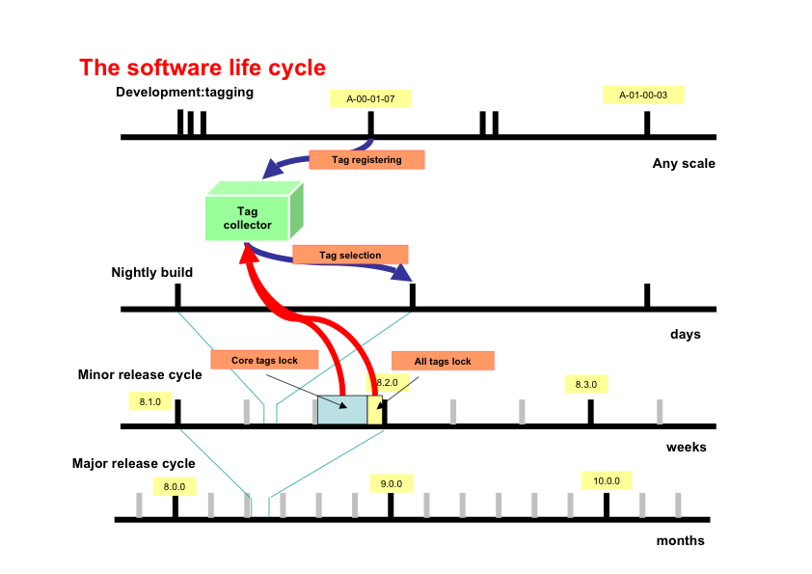

Figure 1: The software life cycle - different time scales for different types of releases.
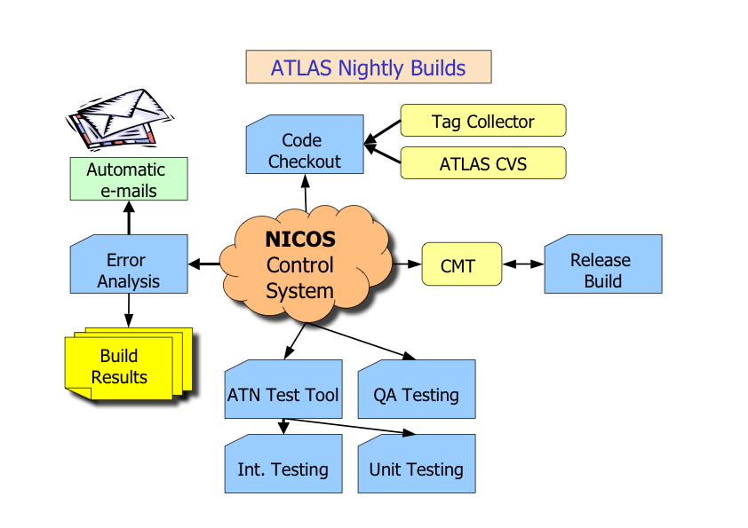
Figure 2: The architecture of the Nightly Build and Test system (NICOS)

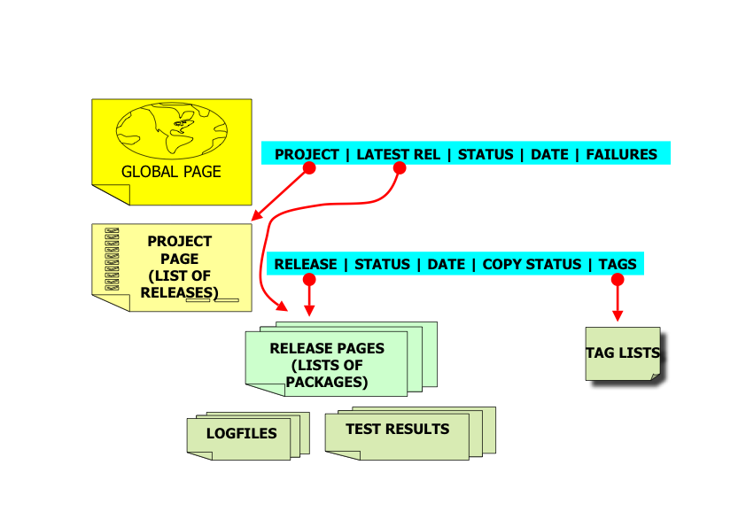

Figure 3: Information provided for each Nightly Build and Test.

MSLOC = 10⁶ Source Lines of Code

