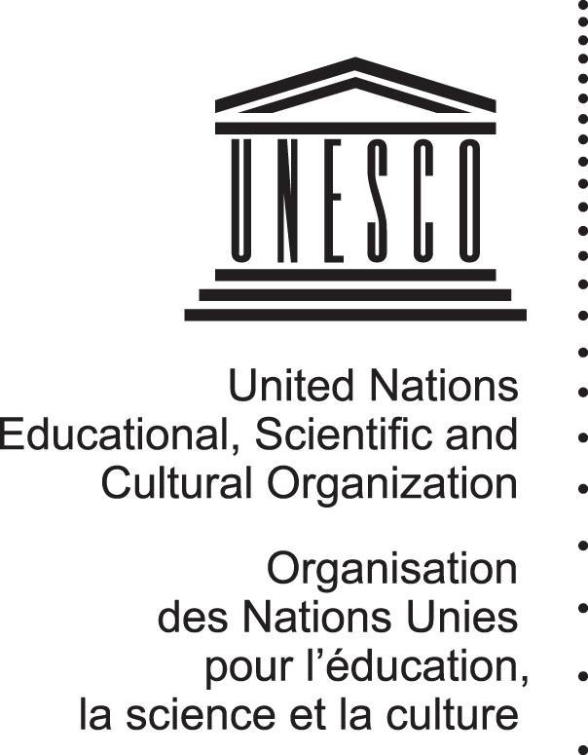
World Heritage 34 COM
Distribution Limited WHC-10/34.COM/7C
Paris, 2 July 2010
Original: English / French

UNITED NATIONS EDUCATIONAL, SCIENTIFIC
AND CULTURAL ORGANIZATION

CONVENTION CONCERNING THE PROTECTION OF
THE WORLD CULTURAL AND NATURAL HERITAGE

World Heritage Committee

Thirty-fourth session
Brasilia, Brazil
25 July - 3 August 2010

Item 7C of the Provisional Agenda: Reflection on the trends of the state of conservation

SUMMARY

As requested by the World Heritage Committee in Decision 33 COM 7C (Seville, 2009), this document contains a summary of the perceived trends, changes and threats on the state of conservation of properties inscribed on the World Heritage List. It is based on an analytical summary of the state of conservation of World Heritage properties examined by the World Heritage Committee since its 29th session (Durban, 2005) until its 33rd session (Seville, 2009).

Decision required: 34 COM 7C, See Point VII.

INTRODUCTION
- With Decision 32 COM 7B.12, the World Heritage Committee requested the World Heritage Centre to prepare, after consultation with the Chairperson, an analytical summary of the state of conservation of the World Heritage properties discussed at the 32nd session (Quebec City, 2008) identifying perceived trends for distribution to the Committee members and discussion at the 33rd session in 2009.
- At its 33rd session (Seville, 2009), the World Heritage Committee requested the World Heritage Centre to prepare, in consultation with the Chairperson, a summary of the perceived trends, changes and threats to World Heritage properties based on an analytical summary of the state of conservation of World Heritage properties over five years. This document provides such analytical summary, undertaken by the World Heritage Centre, based on an analysis of the state of conservation reports that were examined by the Committee at its 29th (Durban, 2005), 30th (Vilnius, 2006), 31st (Christchurch, 2007), 32nd (Quebec City, 2008) and 33rd (Seville, 2009) sessions.
- It should be noted that, over time, the World Heritage Committee had a number of thematic debates on recurrent as well as new and emerging issues considered as threats to World Heritage properties, including fires, extractive industries (mining, oil and gas), developments (road, dams, real estate, etc.), illegal logging, poaching, agricultural encroachment, introduced invasive species, climate change, natural disasters,.... Some of these debates led to strategic orientations and policy development, including from extractive industries (World Heritage properties as “no go” areas for mining, oil and gas exploration/exploitation, 27th session in 2003), climate change (29th session in 2005, 30th session in 2006 and 31st session in 2007) or risk preparedness (Strategy on Risk Reduction at World Heritage properties, 30th session in 2006).
- It should also be noted that, at previous Committee sessions, the Advisory Bodies had also commissioned studies and presented, at the 30th session (Vilnius, 2006), analyses and reports assessing data on state of conservation of World Heritage properties and identifying generic threats, underlying key issues and potential trends over time (1993-2003 for the IUCN study and 1994-2004 for the ICOMOS study).
- This document is composed of several Chapters as follows:
Properties considered in the analysis
Factors affecting the Outstanding Universal Value of the World Heritage properties considered in the analysis
Identifying possible trends in the conservation of properties:
          - Analysis according to the types of threats
          - Analysis according to the types of properties (natural/cultural)
          - Analysis per region

Properties considered in the analysis
- As indicated in the introduction of Document WHC-10/34.COM/7B, the World Heritage Centre and the Advisory Bodies report annually to the World Heritage Committee on the state of conservation of a number of World Heritage properties facing various threats.
- It is important to consider the selection process for the state of conservation reports (“SOC reports”) in accordance with reactive monitoring process outlined in Chapter IV.A of the Operational Guidelines. Furthermore, it should be noted that the selection of these reports by the World Heritage Centre and the Advisory Bodies is only the “tip of the iceberg”, as such reports are being prepared under the Agenda Item 7B, only in cases where actions have to be taken at the World Heritage Committee level; and only the properties facing the most serious threats are reported on each year. Other properties, with less serious or imminent threats are not necessarily reported upon.
- Since its 29th session (Durban, 2005), the World Heritage Committee has reviewed 766 SOC reports, distributed as shown on Chart 1 below. The analysis of threats in the present document is based on those 766 reports. However, it is important to note that, considering that only a small number of Mixed properties is examined each year by the World Heritage Committee (3 or 4) and that any statistical analysis on such small numbers would not have any significance. The threats affecting Mixed properties are classified with Natural properties if the threats affect the natural criteria and with the Cultural properties if the threats affect the cultural criteria.
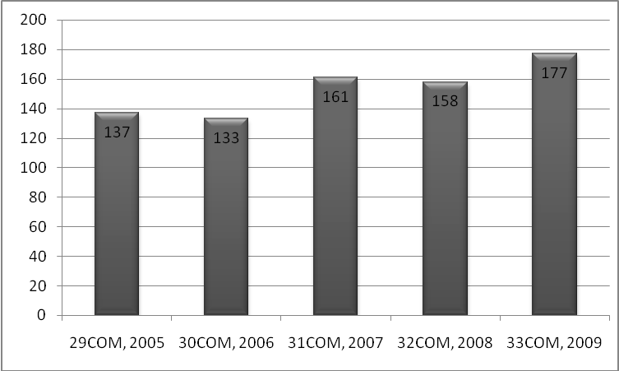
Chart 1: Total number of SOC reports presented at each World Heritage Committee session
since 2005
- Even though the number of SOC reports examined by the World Heritage Committee has varied over time (133 in 2006 to 177 in 2009), the percentages of SOC reports of each region have not varied significantly since 2005 (see Table 1.C below).
- The percentage of properties being reported on since 2005 for each region more or less matches the percentage of properties of each region inscribed on the World Heritage List, with a higher rate of reporting however for the African and Arab States regions (see Table 1.A and 1.C below). The percentage of properties from the Europe and North America region reported on to the Committee is less (around half of the World Heritage List is from Europe and North America but only around a third of the SOC reports are from this region).
 | Africa | Arab  States | Asia-  Pacific | Europe  and North America | Latin America and the Caribbean
Table 1.A) Percentage of properties on the World Heritage List
2005 | 8 | 7.5 | 20 | 50.6 | 13.9
2006 | 8.1 | 7.6 | 20.3 | 51 | 14
2007 | 8.5 | 7.6 | 20 | 50 | 13.9
2008 | 8.7 | 7.4 | 20.4 | 49.7 | 13.8
2009 | 8.7 | 7.4 | 20.7 | 49.5 | 13.7
Table 1.B) Percentage of properties on the List of World Heritage in Danger
2005 | 40 | 17.1 | 22 | 11.4 | 8.6
2006 | 38.2 | 17.6 | 23.5 | 8.8 | 11.8
2007 | 40 | 13.3 | 23.3 | 13.3 | 10
2008 | 40 | 16.7 | 20 | 10 | 13.3
2009 | 40 | 16.7 | 20 | 10 | 13.3
Table 1.C) Percentage of state of conservation reports examined by the World Heritage Committee per region
2005 | 18.1 | 13 | 23.2 | 34.1 | 11.6
2006 | 22.6 | 15 | 23.3 | 28.6 | 10.5
2007 | 18.8 | 13.8 | 23.1 | 31.3 | 13.3
2008 | 14.9 | 9.8 | 19 | 32.8 | 14.4
2009 | 17.8 | 10.9 | 21.3 | 36.8 | 14.9
Table 1: Percentage of the total number of World Heritage properties per region
Percentage of the total number of properties on the List of World Heritage in Danger per region
Percentage of the total number of SOC reports presented per region
- Since 2005, even though 50% of the World Heritage properties are located in Europe and North America, they represent 10% of the List of World Heritage in Danger. By contrast, the African region has less than 9% of the total number of World Heritage properties but they represent around 40% of the properties on the List of World Heritage in Danger. It can also be noticed that there is a higher percentage of properties within the Arab States region on the List of World Heritage in Danger. The figures are more proportionate for the Asia-Pacific region and the Latin America and the Caribbean region (see Table 1.A and 1.B below) for which the percentages of properties inscribed on the World Heritage List and on the List of World Heritage in Danger are similar, being 20% and 13% respectively.
- The important representation of Africa on the List of World Heritage in Danger is of course distorted by the five properties on this List situated in the Democratic Republic of the Congo, all of which were included as a result of the impact of the conflict situation which affected this country. It needs indeed to be noted that the majority of natural properties inscribed on the List of World Heritage in Danger were affected by the impacts of conflict and political instability at the time of their inscription.

Factors affecting the Outstanding Universal Value of the World Heritage properties considered in the analysis
- The current format of the state of conservation reports presented to the World Heritage Committee includes a section where threats (or factors) affecting the Outstanding Universal Value of the property identified either at the time of inscription or in previous reports are listed. These factors have been reviewed and analyzed according to the standardized list of factors affecting the World Heritage properties designed during the revision of the Periodic Reporting questionnaire (see Annex 1), and have been grouped into five primary groups of threats. The full list of factors can be found in Document WHC-08/32.COM/INF.11E (Section II).
- In order to have a consistent approach on all the properties examined throughout the different regions of the world and the categories of heritage (such as natural or cultural), the same factors/threats have been used as in Section II of the Periodic Reporting. This should also make the analysis of potential trends over the years more consistent. The primary and secondary threats are grouped as follows:
- Development and infrastructure:
- Buildings and development
- Transportation infrastructure
- Utilities or service infrastructure
- Pollution
- Physical resource extraction

- Other human activities:
- Biological resource use/ modification
- Social/ cultural uses of heritage
- Other human activities
- Translocated or genetically modified species

- Natural events and disasters:
- Local conditions affecting physical fabric
- Climate and severe weather events
- Sudden ecological or geological events
- Invasive/ alien species or hyper-abundant species

- Management and legal issues:
- Management and institutional factors
Other issues:
Other issues (such as risk of or collapse or deterioration due to age of building, problem of stability of the structures, etc…)

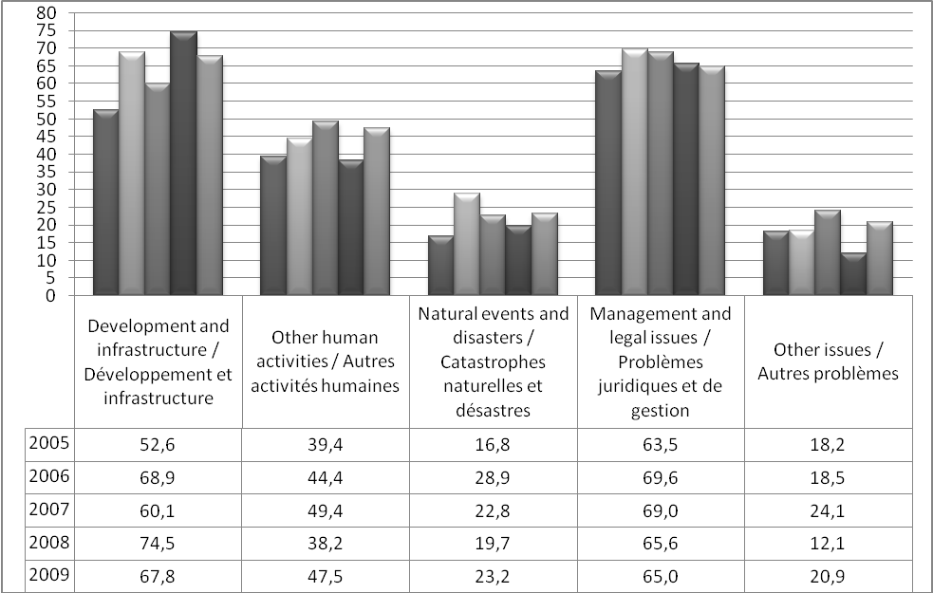
Chart 2: Percentage of properties affected by each primary group of threats
(years progressing from 2005 to 2009, from left to right)

- It should be noted that in most cases, more than one threat affects the Outstanding Universal Value of a property. For the 137 properties considered in 2005, 442 different threats have been identified (an average of 3.2 threats per property). The average number of threats facing a property has been 3.7, 3.9, 3.7 and 3.7 respectively in 2006, 2007, 2008 and 2009. The average number of threats facing each property has remained stable between 3 and 4 over the five years. This also shows the complexity of managing World Heritage properties with a large range of issues to deal with simultaneously. It is important to consider that only the most serious threats are reported upon. Properties might also be affected by much smaller threats which are not included in the SOC reports.
- Globally, over the 5 years considered, each of the five main groups of threats affects the properties with the same frequency (see Chart 2). The issues regarding Development and infrastructure and related to Management remain however the most worrisome ones impacting on an average of 65% of the properties. An increase of nearly 22.5 points can be noted in the percentage of properties faced with Development and infrastructure issues (from 52% in 2005 up to 74.5% in 2008)..

IDENTIFYING POSSIBLE TRENDS IN THE CONSERVATION OF PROPERTIES
- The following section presents the results of a first analysis carried out by the World Heritage Centre. Due to time constraints, this analysis provides a first summary of the base data on trends.
- The figures discussed in this document have not been tested for their statistical significance. Given that sample sizes fluctuate widely between the variables being assessed, it is not possible to give one standard confidence level in the difference measured between variables, from year to year. Furthermore, the number of properties examined for a number of variables are likely too small (e.g. less than 30) for differences to be statistically significant. This situation makes it difficult, at this stage, to arrive at any particular conclusions in regards to statistically ascertained trends for most studied variables.

A) Analysis according to the five primary groups of threats
Primary group of threats | Secondary threats | 2005 | 2006 | 2007 | 2008 | 2009
Development and infrastructures | - Buildings and development | 32,1 | 43,6 | 35,4 | 51,3 | 41,8
Development and infrastructures | - Transportation infrastructure | 13,1 | 12,8 | 16,8 | 20,9 | 19,8
Development and infrastructures | - Utilities or service infrastructure | 8,75 | 8,3 | 8 | 10,8 | 6,8
Development and infrastructures | - Pollution | 5,1 | 7,5 | 8 | 8,2 | 5,1
Development and infrastructures | - Physical resource extraction | 14,6 | 9,7 | 9,9 | 11,4 | 9,6
Other human activities | - Biological resource use/ modification | 18,2 | 18 | 18,6 | 11,4 | 14,1
Other human activities | - Social/ cultural uses of heritage | 18,2 | 12,8 | 22,3 | 5,1 | 19,2
Other human activities | - Other human activities (illegal activities such as poaching, logging, civil unrest, ...) | 21,1 | 27 | 27,7 | 30,4 | 31,1
Other human activities | - Translocated or genetically modified species | 0 | 0 | 0 | 0 | 0
Natural events  and disasters | - Local conditions affecting physical fabric | 2,2 | 9 | 9,3 | 10,1 | 7,9
Natural events  and disasters | - Climate and severe weather events | 2,2 | 6,7 | 5,6 | 3,2 | 4,5
Natural events  and disasters | - Sudden ecological or geological events | 9,4 | 11,2 | 11,2 | 7,0 | 9,0
Natural events  and disasters | - Invasive/ alien species or hyper-abundant species | 3,6 | 6,7 | 3,7 | 4,4 | 4,5
Management  and legal issues | - Management and institutional factors | 63,5 | 69,6 | 69 | 63,9 | 66,1
Other issues | - Other factor(s) | 18,2 | 18,5 | 24,1 | 12,1 | 20,3
Table 2: Percentage of properties affected by each of the secondary threats

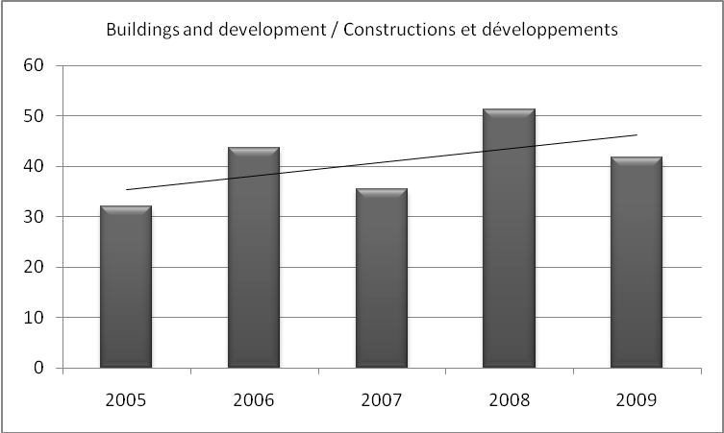
      - Development and infrastructure projects
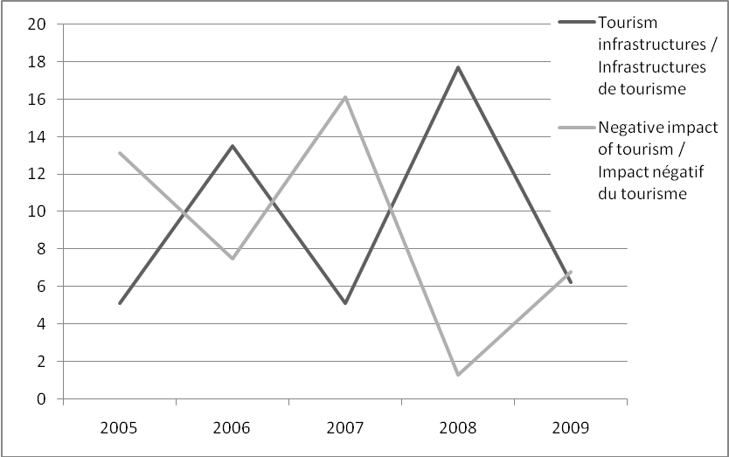
Chart 3: Percentage of properties affected by Buildings and development projects
Chart 4: Percentage of properties affected by tourism infrastructures
and by the negative impact of tourism
- The important decrease in the percentage of properties affected by Buildings and development is worth mentioning (see Chart 3). Indeed, from 51% in 2008, this has decreased to 42% of the properties as being threatened by this type of projects in 2009. Some of these projects are tourism-oriented development projects (17.7% of the properties were affected by these projects in 2008 down to 6.2% in 2009) (see Chart 4 above). However, this remains an important threat to World Heritage properties, and States Parties are encouraged to conform to Paragraph 172 of the Operational Guidelines and notify the World Heritage Centre of any development projects potentially affecting an inscribed property.

- It is interesting to notice that a peak in terms of tourism-oriented development projects (13,5% of properties affected in 2006) is followed, in the Chart, by an increase in the negative impact of tourism the following year (16,1% of the properties affected in 2007, up from 7.5% in 2006) (see Chart 4). On the other hand, when the threats of tourism development projects decreases, there is a drop the following year in terms of properties affected by the negative impact of tourism, and this could be linked. Perhaps, this could be explained by the fact that once the threat is removed; the SOC report is no longer examined by the World Heritage Committee.
- High-rise buildings projects impacting on the visual integrity/aesthetic values of the properties appear to be affecting more and more properties over the years: a rise from 2.2% of the properties reported on in 2005 to nearly 5% in 2009 (see Chart 5). As could be expected, all properties affected by high-rise buildings are cultural properties; these represent 7.2% of the cultural properties reported on in 2009, up from 3.2% in 2005.
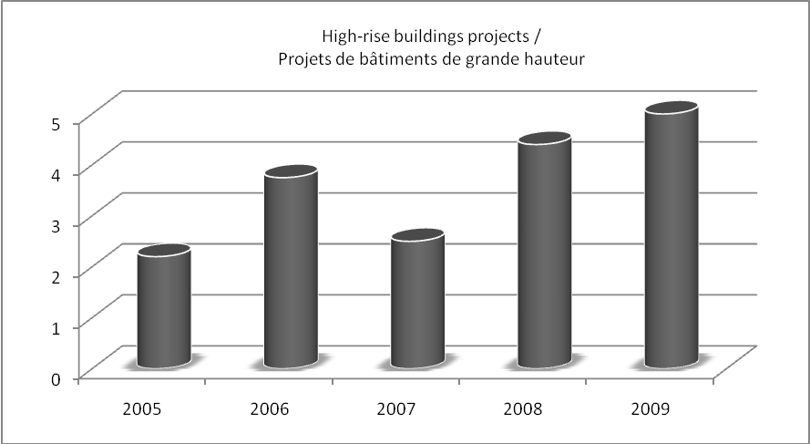
Chart 5: Percentage of properties affected by high-rise building development projects

- The threats linked to Utilities and service infrastructure are mainly caused by dam development projects (see Chart 6) and their associated impacts. On average, 75 to 90% of the affected properties are natural. Development of dams represents the highest threat amongst the Utilities and service infrastructures (between 58% in 2009 and 90% in 2006). There is, although not necessarily significant, a slight drop of this threat (9.5% in 2008 down to 3.9% in 2009).
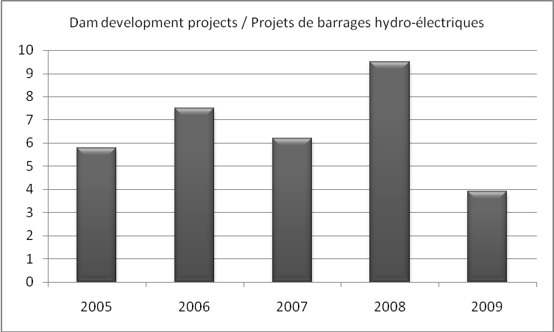
Chart 6: Percentage of properties reported on and affected
by hydro-electric dam development projects
- As far as mining is concerned, an average of 8.4% of the properties reported on since 2005 are affected; this represents around a quarter of all the natural properties reported on. Even though stable over the years, and besides the adoption by the International Council on Mining and Metals (ICMM) in 2003 of a position statement indicating that “ICMM member companies undertake not to explore or mine in World Heritage properties. All possible steps will be taken to ensure that existing operations in World Heritage properties as well as existing and future operations adjacent to World Heritage properties are not incompatible with the outstanding universal value for which these properties are listed and do not put the integrity of these properties at risk”, this threat remains high and was the object of recurrent debates during World Heritage Committee sessions.
- Threats due to Oil and gas exploitation seem to have decreased since 2005. Indeed, affecting 3.6% of the properties reported on in 2005, this threat affected only 1.7% of them in 2009.

      - Other human activities
- Although, Agricultural encroachment and cattle grazing represent an important threat to World Heritage properties (mainly natural properties), 14.6% of the properties were affected by this factor in 2005, to around 7% (7% in 2008 and 7.3% in 2009).
- Over the years, there has been an important increase of threats due to illegal activities (poaching, illegal logging, vandalism), war, civil unrest (see Chart 7). This factor now affects more than 30% of the properties (31.6% in 2009), up from 20.4% in 2005. It is also worth noting that more than one third of them is affected by at least two illegal activities in conjunction (35.6% on average); in a number of cases, the key factor that appears to prompt the illegal activities is civil unrest or an armed conflict in the country.
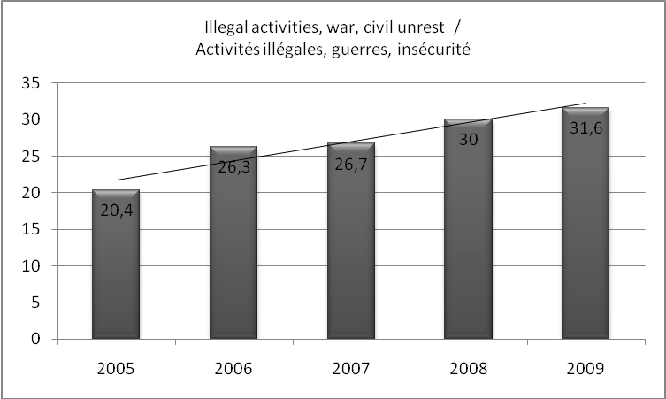
- Over the years, armed conflicts, political instability and civil unrest have consistently remained a threat to World Heritage properties. On average, 8.6% of the properties reported on to the World Heritage Committee are facing this type of threat since 2005.
Chart 7: Percentage of properties reported on which are affected by “Other human activities”
(poaching, illegal logging, other illegal activities, war, civil unrest)
- Looking at the types of properties affected by armed conflicts, political instability and civil unrest, it should be noted that a very large majority of them are natural properties. However, since 2005, more cultural properties appear to have been affected (7.7% in 2005 to 33.4% in 2009) (see Chart 8).
- Finally, as evidenced in Chart 8 below, more than 80% of the properties affected by civil unrest, political instability or war are inscribed on the List of World Heritage in Danger (100% of them in 2007). Degradation as a result of conflict and political instability or security issues seems to be the main driver which leads to the inscription of natural properties on the List of World Heritage in Danger. Out of the 15 natural properties on this List currently, impacts from conflict and insecurity were a main motivation at the time of their inscription for 11 properties.
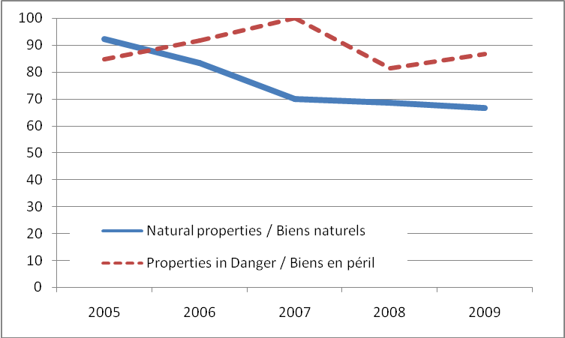
Chart 8: Percentage of properties reported on and affected by armed conflicts, political instability
and civil unrest (chart showing both Natural properties and
properties inscribed on the List of World Heritage in Danger)

      - Natural events and disasters
- Since 2005, this factor has been affecting World Heritage properties in a consistent manner (around 20% of properties examined).
- As shown in Chart 9 below, since 2005, the threat from Invasive species affects more or less the same number of properties (around 4%) each year. The same trend applies to the threat related to Climate and severe weather events which have been affecting an average of 4.4% of the properties each year. In order to address this issue, the 16th General Assembly of States Parties to the World Heritage Convention adopted in 2007 a “Policy document on the impacts of climate change on World Heritage properties" (Doc. WHC-07/31.COM/7.1 at http://whc.unesco.org/en/sessions/31COM/documents/). Furthermore, the World Heritage Committee is very concerned by the climate change threat and has reviewed this issue several time during its sessions (Decisions 29 COM 7B.a; 30 COM 7.1; 31 COM 7.1; 32 COM 7B.129 and 33 COM 7B.148).
- A slight decrease in the sudden ecological or geological events threat from 12.4% in 2005 to 8.4% in 2009 can also be noticed. In order to assist States Parties to protect World Heritage properties against such events, the World Heritage Committee adopted at its 31st session (Christchurch, 2007) a “Strategy for Reducing Risks from Disasters at World Heritage properties” (Document WHC-07/31.COM/7.2 at http://whc.unesco.org/en/sessions/31COM/documents/) and recommended that a risk management component be incorporated in the Management Plan for World Heritage properties in accordance with Paragraph 118 of the Operational Guidelines.
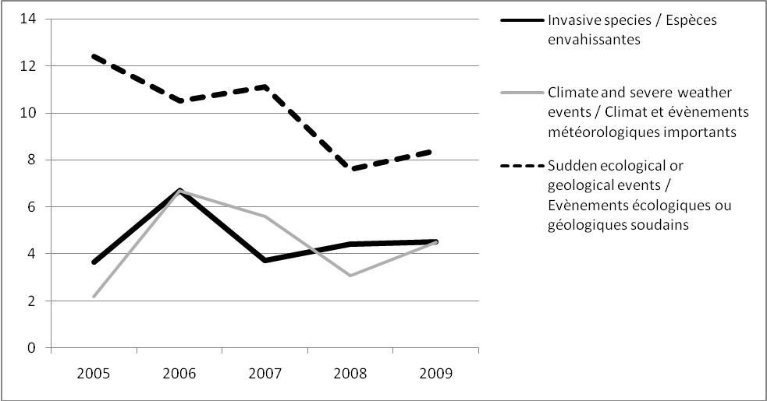
Chart 9: Percentage of properties affected by various natural events and disasters

      - Management and legal issues
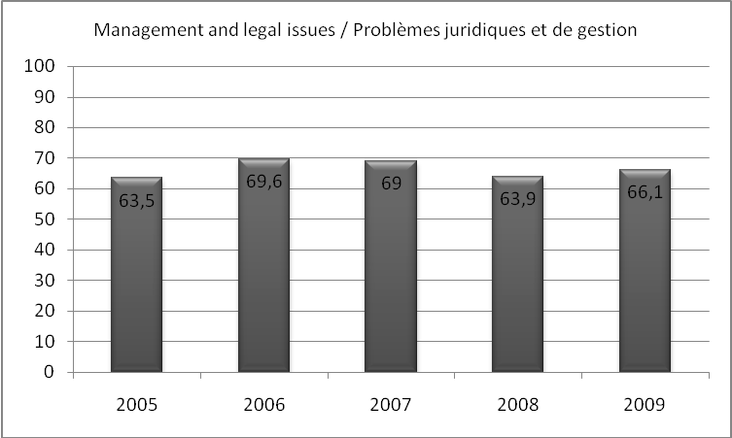
Chart 10: Percentage of properties affected by Management and legal issues since 2005
- As evidence in Table 2 and Chart 10 above, the Management and legal issues represent one of the key threats to World Heritage properties, and have done so consistently since 2005. Indeed, more than two thirds of the properties (between 63.5% in 2005 and 69.6% in 2006) are affected by this threat.

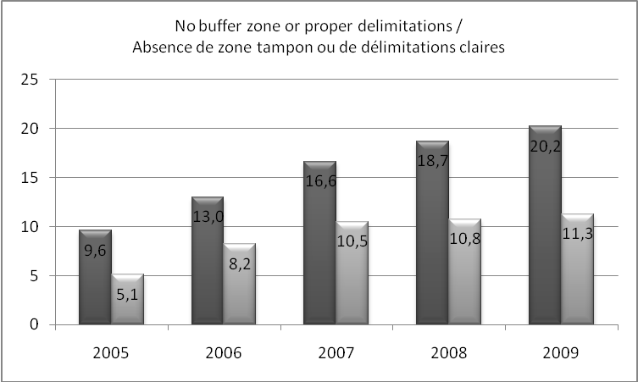
Chart 11: Percentage of properties with no buffer zone or no clear delimitations of boundaries
(left: percentage of those properties out of all the properties with Management issues)
(right: percentage of those properties out of all the properties examined by the Committee)
- It is worth noting (see Chart 11 above) that in 2009, 20.2% of the properties affected by Management and legal issues were threatened due to either the lack of boundaries, lack of clear boundaries or lack of a buffer zones. This threat is on the increase as 2005, when only 9.6% of the properties had this issue, it has more than doubled over the past five years and is now a threat for more than 10% of the overall number of properties examined by the World Heritage Committee (11.3% in 2009).
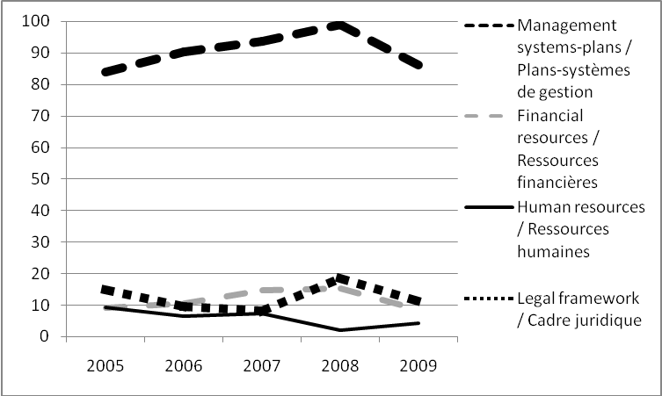
Chart 12: Percentage of properties affected by various management and legal issues
- Since 2005, between 83% and 98.9% of properties facing Management and legal issues are threatened by the lack of a management plan or system (nearly 100% in 2008). This is emerging as, by far, the most important threat to World Heritage properties in this group. Indeed, the other factors of this group such as lack of financial and/or human resources, and lack of legal framework, never affect more than 20% of the properties facing Management and legal issues (see Chart 12 above). There has however been a drop of 12 points between 2008 and 2009 for the properties with no Management plan or system and of 7 points for the properties with no legal framework. The figures also tend to show that some of the properties which were provided with a management plan or system are still threatened due to the lack of implementation of the latter.
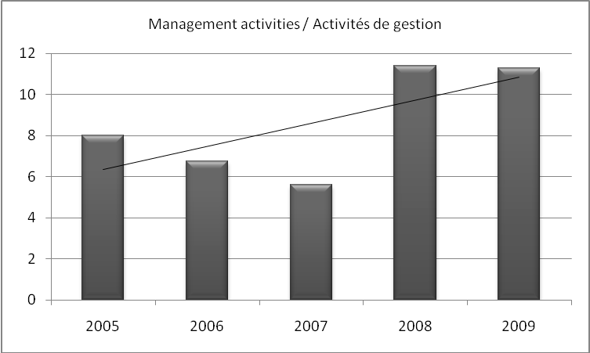
Chart 13: Percentage of properties affected by inadequate management activities

- Finally, it is important to highlight that an increasing number of properties is under threat from inappropriate conservation/management activities (e.g. negative impact of rehabilitation projects on the protection of the traditional urban tissue of an historic centre, unsuitable restoration techniques, loss of authenticity due to recent restoration works, low quality of repairs and reconstruction, etc...) which negatively impact on the attributes that convey the Outstanding Universal Value of the property and on its authenticity/integrity. While in 2005, 8% of the properties faced such a threat, more than 10% were threatened in 2009 (see Chart 13 above).
      - Other issues
- The number of properties whose threats came under this group has remained stable since 2005. Indeed, in 2005, 18.2% of properties were affected by the fragile structure of the buildings, degradation due to the age of the monuments or collapse or imminent risk of collapse; and there are still 20.2% in 2009. All these threats could be addressed in a proper management plan or system that addressed conservation activities.

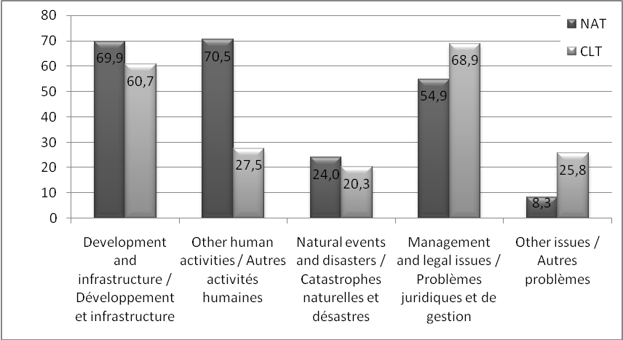
B) Analysis per type of properties (natural or cultural properties)
Chart 14: Average percentage of natural (left) and cultural (right) properties
affected by each of the five primary groups of threats between 2005 and 2009

- Globally (see Chart 14 above), one can notice that, even though the Development and infrastructure threats, Management and legal issues, and Other human activities (for natural properties) remain the main threats affecting World Heritage properties over the years, they affect natural and cultural properties differently.
- Development and infrastructure
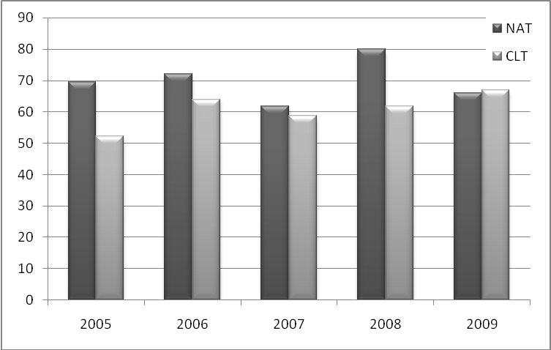
Chart 15: Percentage of properties affected by Development and infrastructure projects
(NAT: natural properties; CLT: cultural properties)
- It is noteworthy that over the years, while more cultural properties have been affected by Development and infrastructure projects (respectively 52.2% in 2005 to 60.7% in 2009%) yet this threat has remained similarly high for natural properties (69.4% in 2005 and 66.1% in 2009) (see Chart 15 above). The drop of 14 points for the natural properties between 2008 and 2009 is most probably due to the fact that, as indicated above, in 2008, the major threat was the building of tourism infrastructures (which falls under “Development and infrastructures – Buildings and development”), yet in 2009, the tourists themselves and the pressure they put on the properties represent the main threat, thus falling under the “Other human activities - Social/cultural uses of heritage” threat (see Chart 16 below).

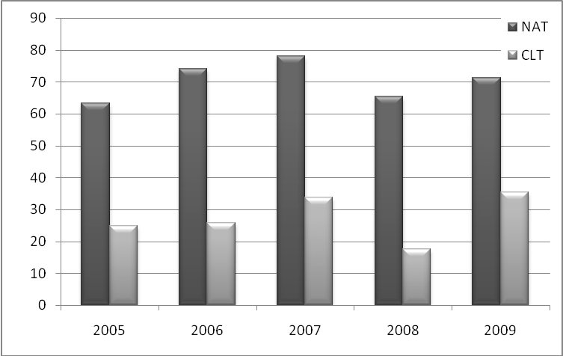
- Other human activities
Chart 16: Percentage of properties affected by Other human activities
(NAT: natural properties; CLT: cultural properties)
- Other human activities consist mainly of poaching, illegal timber exploitation, civil unrest, agricultural encroachment, grazing, negative impact of tourism, changes in local population and communities, explaining why mostly natural properties are affected (see Chart 16 above). This is the highest threat to natural properties; since 2005, an average of 70.5% of the natural properties reported on is affected by this threat.
- Out of the 49 to 55 natural properties examined each year since 2005, an average of 25% is affected by mining activities, which is a stable threat over the years (variation between 22 and 28%).
- The impact of tourism is one of the emerging threats to World Heritage properties in 2008, be it for natural or cultural properties. However, this could also be seen as an opportunity, with proper public use planning and management. It should be noted that out of the 24 properties affected in 2009, 12 were cultural and 12 natural.
- Armed conflicts, political instability, civil unrest is still an important threat to World Heritage properties. Since 2005, out of all the properties reviewed by the World Heritage Committee and affected by this threat; 76.2% were natural properties and 23.8% cultural properties. The natural properties affected by this factor represent about a quarter of all the natural properties reported on; yet the cultural properties affected are increasing and represent 4% of all the cultural properties reported on in 2009, up from 1% in 2005.

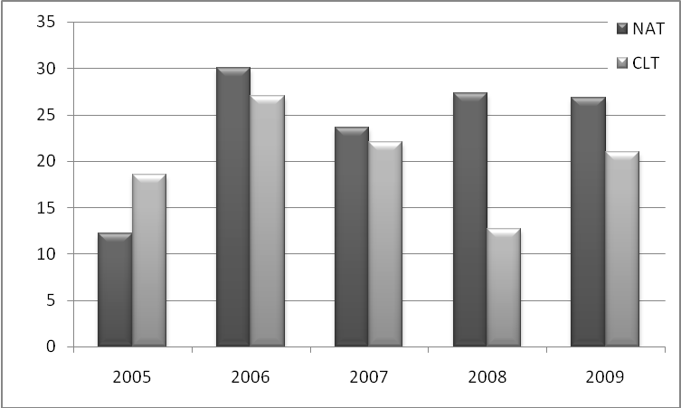
- Natural events and disasters
Chart 17: Percentage of properties affected by Natural events and disasters
(NAT: natural properties; CLT: cultural properties)
- Over the studied 5-year period (see Chart 17 above), we can notice an increase in the number of natural properties affected by Natural events and disasters (from 12% in 2005 to 27% in 2009). Cultural properties have significantly increased between 2008 and 2009 (from 12.7% to 21%). However, the nature of the threat differs between the two categories of properties.
- Indeed, cultural properties are mostly affected by the impact of wind, humidity, earthquakes, fires, and natural decay, while natural properties are mostly affected by the impact of climate change, invasive species and cyclones. One also has to consider the fact that natural properties may recover more easily from earthquakes in comparison to the built environment; earthquake representing therefore a lesser threat to natural properties.

- Management and legal issues
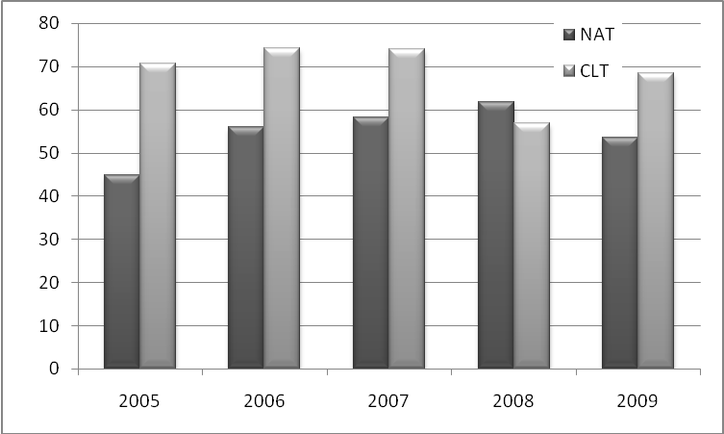
Chart 18: Percentage of properties affected by Management and legal issues
(NAT: natural properties; CLT: cultural properties)

- The figures of Chart 18 (see above) show that overall, cultural properties appear to be more sensitive to the lack of proper conservation, or to lack of a management plan or system than natural properties (there is an average difference of 14 points between natural and cultural properties affected by this threat during the 5-year period).

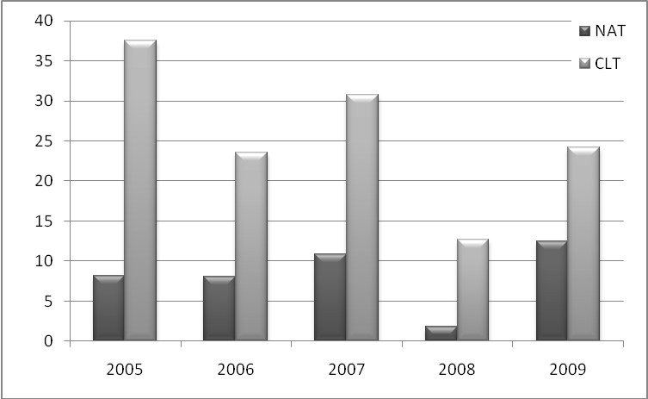
- Other issues
Chart 19: Percentage of properties affected by Other issues
(NAT: natural properties; CLT: cultural properties)
- This group of threats affects mostly cultural properties (an average of 25.7% of cultural properties is affected compared to 8% of the natural properties) (see Chart 19 above). This is understandable as this category of threats consists mainly of the fragile structure of buildings, degradation due to the age of monuments or collapse or imminent risk of collapse.

C) Analysis per region
 |  | Africa | Arab States | Asia-Pacific | Europe and North America | Latin Am. and the Caribbean
Development and infrastructure projects | 2005 | 44 | 81 | 50 | 62 | 81
Development and infrastructure projects | 2006 | 60 | 80 | 61 | 84 | 50
Development and infrastructure projects | 2007 | 57 | 72 | 51 | 62 | 62
Development and infrastructure projects | 2008 | 85 | 76 | 67 | 81 | 56
Development and infrastructure projects | 2009 | 74 | 74 | 62 | 69 | 46
Other human activities | 2005 | 56 | 25 | 47 | 32 | 37
Other human activities | 2006 | 63 | 45 | 36 | 34 | 50
Other human activities | 2007 | 70 | 41 | 48 | 37 | 57
Other human activities | 2008 | 62 | 41 | 39 | 23 | 44
Other human activities | 2009 | 77 | 58 | 49 | 27 | 50
Natural events  and disasters | 2005 | 20 | 37 | 3 | 15 | 25
Natural events  and disasters | 2006 | 30 | 55 | 12 | 21 | 50
Natural events  and disasters | 2007 | 37 | 36 | 13 | 8 | 38
Natural events  and disasters | 2008 | 12 | 24 | 18 | 18 | 32
Natural events  and disasters | 2009 | 32 | 37 | 19 | 11 | 35
Management  and legal issues | 2005 | 64 | 75 | 62 | 60 | 69
Management  and legal issues | 2006 | 70 | 90 | 70 | 52 | 85
Management  and legal issues | 2007 | 63 | 82 | 60 | 75 | 67
Management  and legal issues | 2008 | 62 | 82 | 64 | 61 | 68
Management  and legal issues | 2009 | 68 | 84 | 57 | 53 | 85
Other issues | 2005 | 24 | 69 | 12 | 8 | 0
Other issues | 2006 | 30 | 30 | 9 | 13 | 14
Other issues | 2007 | 30 | 31 | 24 | 19 | 19
Other issues | 2008 | 19 | 29 | 6 | 7 | 12
Other issues | 2009 | 35 | 37 | 14 | 13 | 23
Table 3. Percentage of properties of each region affected by each of the five primary groups of threats
(Darker grey indicates a high percentage of the concerned properties).

 | Africa | Arab States | Asia-Pacific | Europe and North America | Latin Am. and the Caribbean
Development  and infrastructure projects |  | = | = | = | 
Other human activities |  |  | = | = | =
Natural events  and disasters | = | = |  | = | =
Management  and legal issues | = | = | = | = | =
Other issues | = |  | = | =
( INCREASING - DECREASING - = STABLE HIGH - = STABLE LOW )
Table 4. Trends showing how each region has been affected by each of the five primary groups
of threats over the 5-year period studied (2005-2009)
- Through this regional analysis, over the 5-year period considered (2005-2009), one can notice that throughout the regions, the two main groups of threats affecting World Heritage properties are Development and infrastructure as well as Management and legal issues (see Tables 3 and 4 above). Since 2005, these two groups have generally affected more than 50%, and up to 90%, of the properties in any given region.
- This regional analysis aims at indicating the main threats affecting the region and could give an indication for the theme of future regional programmes to be developed.
- Africa
- In Africa, the major threats affecting the concerned properties are related to Development and infrastructure (mostly since 2008), Management and legal issues and Other human activities, all affecting more than two thirds of the properties of the region. The threat related to Development and infrastructures is less in 2009 than it was in 2008, but this is not specific to this region as this trend can be seen throughout the different regions. The reason has been explained above. All other threats are stable, at a lower level (between 20% and one third of the properties affected).
- Arab States
- In the Arab States region, the main threats remain in relation to Development and infrastructure and Management and legal issues with more than 75% of the properties being concerned. It should be noticed that the threat linked to Other human activities is on the increase in this region. This is mainly due to an increase of deliberate destructions of heritage, alterations of the urban fabric or illegal constructions.
- Asia-Pacific
- As far as the Asia-Pacific region is concerned, properties are also mainly affected by Development and infrastructure and Management and legal issues, but in a lesser extent than for other regions, with slightly less than two thirds of the properties being affected since 2005. Asia-Pacific is the only region where the threat related to Natural events and disasters has increased since 2005 (from 3% of the properties affected in 2005 to almost 20% in 2009) due to earthquakes, cyclone damages, etc...
- Europe and North America
- The Europe and North America region properties are very affected by Development and infrastructure projects with more than two thirds of properties examined being affected. It is the only region where all the threats remain more or less at the same level since 2005. Furthermore, the very large majority (more than 90%) of the properties facing high-rise building development issues are located in Europe and North America.
- Latin America and the Caribbean
- Finally, over the past five years, the highest threat for the Latin America and the Caribbean region properties relates to Management and legal issues with an average of 75% of the properties being affected. It is worth noting that the Latin America and Caribbean region is the least affected by Development and infrastructures of all the regions, with half of its properties being affected, compared to more than 2 thirds for the other regions. Furthermore, it is the only region where this trend seems actually to be decreasing since 2005 when 81% of the properties were threatened, compared to 46% in 2009.

CONCLUSION
- This summary analysis of threats to the World Heritage properties examined by the World Heritage Committee since 2005 illustrates:
- The wide range of threats to World Heritage properties;
- The two key groups of threats affecting World Heritage properties are: Development and infrastructure and Management and legal issues for cultural properties and Development and infrastructure and Other human activities for natural properties.
- The absence of Management plan or system remains an important threat to World Heritage properties;
- Inadequate management activities are also, since 2005, increasingly affecting the conditions of authenticity of properties since 2005;
- Issues related to the lack of buffer zone or delimitations of the property, as well as issues due to war, civil unrest and illegal activities are on the increase since 2005;
- Issues linked to mining activities appear to be constant but remain however sufficiently important to require further debate;
- Development of hydro-electric dams and high-rise buildings has been on the increase since 2005. The decrease noticed between 2008 and 2009 does however not permit any conclusion yet.
- The slight differences perceived between threats observed in regions of the world may be related to the types of properties inscribed on the World Heritage List (e.g. Development and infrastructure to cities, Other human activities such as poaching to natural properties).

USEFUL REFERENCES1
- UNESCO World Heritage Centre - http://whc.unesco.org
- ICOMOS : http://www.icomos.org
- IUCN : http://www.iucn.org
- ICCROM : http://www.iccrom.org
- International Council on Mining and Metals (ICMM): http://www.icmm.com
- World Heritage Reports n°22 - Climate Change and World Heritage http://whc.unesco.org/en/series/22/
- World Heritage Series n°10 - Monitoring World Heritage - http://whc.unesco.org/en/series/10/
- Case Studies on Climate Change and World Heritage - http://whc.unesco.org/en/activities/473/
- World Heritage: Challenges for the Millennium - http://whc.unesco.org/documents/publi_millennium_en.pdf

draft decision

Draft Decision: 34 COM 7C
The World Heritage Committee,

Having examined Document WHC-10/34.COM/7C,

Recalling Decisions 32 COM 7B.129 and 33 COM 7C, adopted at its 32nd (Quebec City, 2008) and 33rd (Seville, 2009) sessions respectively,

Welcomes the analytical summary of the perceived trends, changes and threats to the state of conservation of World Heritage properties over the past five years (2005-2009), as the basis for further reflection and more extensive analysis of this information;

Considers that this work highlights the need for more systematic monitoring of threats and of how to identify and react to emerging trends;

Suggests that data on the emergence of trends and on the underlying reasons for the emergence of trends could be helpful to States Parties, to the World Heritage Centre and to the Advisory Bodies;

Given the percentage of threats related to Development and infrastructure projects and to high-rise buildings, stresses the need for structured heritage impact assessments of major projects to be carried out at the earliest opportunity in order to assess the impact of potential projects on Outstanding Universal Value of World Heritage properties;

Recalls the provisions of Paragraph 172 of the Operational Guidelines and that prompt information on potential development projects and their review for impact on Outstanding Universal Value is a key tool for ensuring the effective conservation of World Heritage properties and the credibility of the Convention;

Taking into account the information provided in the introduction of Document WHC-10/34.COM/7B and specifically the impact of natural disasters affecting World Heritage properties, and notes the progress made in the implementation of the Strategy for Disaster Risk Reduction at World Heritage properties as indicated in Document WHC.10/34.COM/7.3, as well as the newly published Resource Manual on this subject;

Also notes that the World Heritage Centre and the Advisory Bodies have considered the approaches for the selection of properties for state of conservation reports and processes for preparing Desired state of conservation statements for the removal of properties from the List of World Heritage in Danger and further notes that these will be subject to a further review at the next World Heritage Centre/Advisory Bodies meeting in September 2010;

Acknowledges the inclusion of links to illustrative material in the state of conservation reports which provide information on potential visual impact on the Outstanding Universal Value of a property and encourages the States Parties to share their experiences concerning visual impact studies and simulations by providing to the Word Heritage Centre links to relevant information to be made available through the web-page;

Requests the World Heritage Centre and the Advisory Bodies to report back on criteria, thresholds and processes relevant to the initiation of state of conservation reports and to the preparation and review of Desired state of conservation statements for the removal of properties from the List of World Heritage in Danger, for examination by the World Heritage Committee at its 35th session in 2010.

Annex 1

List of factors (threats) affecting World Heritage properties
as designed for the Periodic Reporting (revised questionnaire, Section II)

DEVELOPMENT AND INFRASTRUCTURES
3.1. BUILDINGS AND DEVELOPMENT
3.1.1. Housing
3.1.2. Commercial development
3.1.3. Industrial areas
3.1.4. Major visitor accommodation and associated infrastructure
3.1.5. Interpretative and visitation facilities
3.2. TRANSPORTATION INFRASTRUCTURE
3.2.1. Ground transport infrastructure
3.2.2. Air transport infrastructure
3.2.3. Marine transport infrastructure
3.2.4. Underground transport infrastructure
3.2.5. Effects arising from use of transportation infrastructure
3.3. UTILITIES OR SERVICE INFRASTRUCTURE
3.3.1. Water infrastructure
3.3.2. Renewable energy facilities
3.3.3. Non-renewable energy facilities
3.3.4. Localised utilities
3.3.5. Major linear utilities
3.4. POLLUTION
3.4.1. Pollution of marine waters
3.4.2. Ground water pollution
3.4.3. Surface water pollution
3.4.4. Air pollution
3.4.5. Solid waste
3.4.6. Input of excess energy
3.6. PHYSICAL RESOURCE EXTRACTION
3.6.1. Mining
3.6.2. Quarrying
3.6.3. Oil and gas
3.6.4. Water
OTHER HUMAN ACTIVITIES
3.5. BIOLOGICAL RESOURCE USE/ MODIFICATION
3.5.1. Fishing/collecting aquatic resources
3.5.2. Aquaculture
3.5.3. Land conversion
3.5.4. Livestock farming/grazing of domesticated animals
3.5.5. Crop production
3.5.6. Commercial wild plant collection
3.5.7. Subsistence wild plant collection
3.5.8. Commercial hunting
3.5.9. Subsistence hunting
3.5.10. Forestry /wood production
3.8. SOCIAL/ CULTURAL USES OF HERITAGE
3.8.1. Ritual/spiritual/religious and associative uses
3.8.2. Society’s valuing of heritage
3.8.3. Indigenous hunting, gathering and collecting
3.8.4. Changes in traditional ways of life and knowledge system
3.8.5. Identity, social cohesion, changes in local population and community
3.8.6. Positive impacts of tourism/visitor/ recreation
3.8.7. Negative impacts of tourism/visitor/ recreation
3.9. OTHER HUMAN ACTIVITIES
3.9.1. Illegal activities
3.9.2. Deliberate destruction of heritage
3.9.3. Military training
3.9.4. War
3.9.5. Terrorism
3.9.6. Civil unrest
3.12. INVASIVE/ ALIEN SPECIES OR HYPER-ABUNDANT SPECIES
3.12.1. Translocated species
3.12.6. Modified genetic material
NATURAL EVENTS AND DISTASTERS
3.7. LOCAL CONDITIONS AFFECTING PHYSICAL FABRIC
3.7.1. Wind
3.7.2. Relative humidity
3.7.3. Temperature
3.7.4. Radiation/light
3.7.5. Dust
3.7.6. Water
3.7.7. Pests
3.7.8. Micro-organisms
3.10. CLIMATE AND SEVERE WEATHER EVENTS
3.10.1. Storms
3.10.2. Flooding
3.10.3. Drought
3.10.4. Desertification
3.10.5. Changes to oceanic waters
3.10.6. Temperature extremes
3.11. SUDDEN ECOLOGICAL OR GEOLOGICAL EVENTS
3.11.1. Volcanic eruption
3.11.2. Earthquake
3.11.3. Tsunami/tidal wave
3.11.4. Avalanche/ landslide
3.11.5. Erosion and siltation/ deposition
3.11.6. Fire
3.12. INVASIVE/ ALIEN SPECIES OR HYPER-ABUNDANT SPECIES
3.12.2. Invasive/alien terrestrial species
3.12.3. Invasive / alien freshwater species
3.12.4. Invasive / alien marine species
3.12.5. Hyper-abundant species
MANAGEMENT AND LEGAL ISSUES
3.13. MANAGEMENT AND INSTITUTIONAL FACTORS
3.13.1. Legal framework
3.13.2. Governance
3.13.3. Management systems/ management plan
3.13.4. Financial resources
3.13.5. Human resources
3.13.6. Low impact research/monitoring activities
3.13.7. High impact research/monitoring activities
3.13.8. Management activities
OTHER FACTORS
3.14. OTHER FACTOR(S)

