Week: 10 Date: 11/10/2022
15-110 Recitation Week 10

Reminders
- How was Exam 2?
- HW5 due Monday 11/14 at noon.
Overview
- Security Review
- Meme Cipher Encryption
- RSA
- Top Down Preview
- OH

Problems

Security Review
Describe the two main types of authentication.

What makes RSA nearly impossible to break?

Match the descriptions below to the corresponding types of security attack:
Every student at CMU goes to SIO at the same time to check their schedules
Answer: _________________

One malicious student connects to a class wifi access point and looks at the packets for their roommate's andrew ID and password to send prank emails from their accounts
Answer: _________________

Meme Cipher Encryption
Carnegie Mellon | 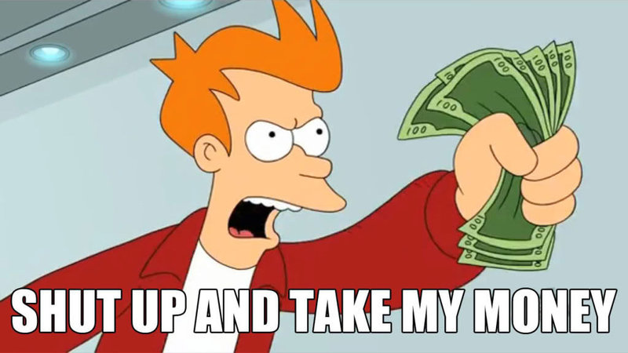
surprised | 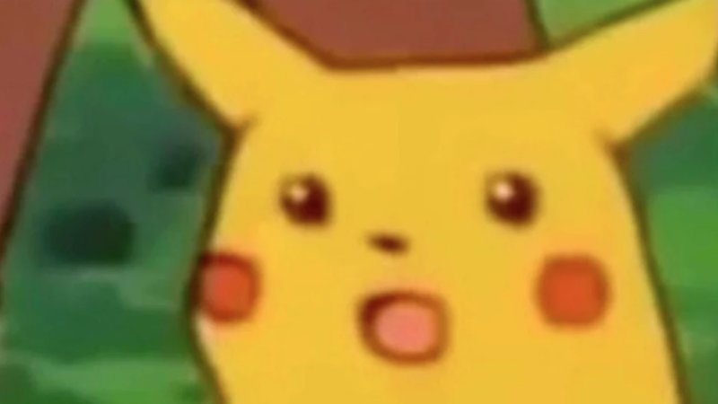
I | 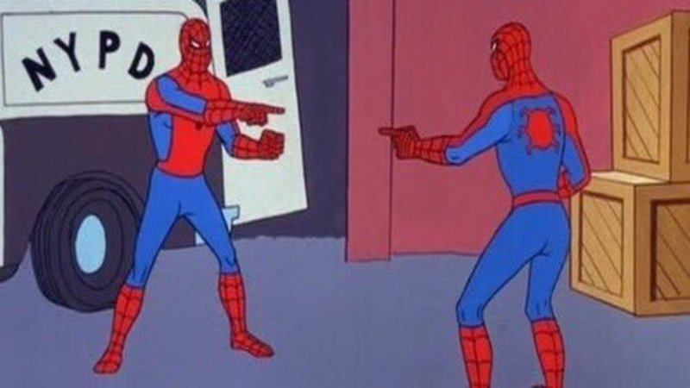
good | 
cool | 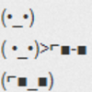
grade | 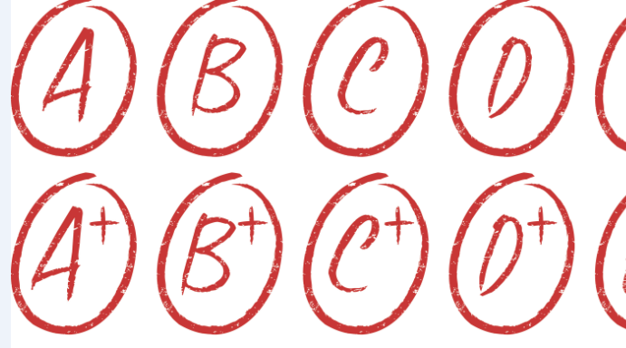
Encrypt:
Carnegie Mellon is cool.

Decrypt:

What is the plaintext? __________________________

What is the ciphertext? _________________________

Is this a symmetric or asymmetric encryption algorithm? _________________________

How many keys are used? _________________________

What is the key? _________________________

What is the runtime to break this cipher? Keep in mind that an adversary knows each meme corresponds to a word, but they don’t know which words are being used in the message. This means they would have to check each possibility in the dictionary. For this question, assume there are N words in the dictionary and 6 memes that are used.

RSA Recap
Elisa wants to send a super secret message to Gabe about the 110 exam. She translates the message into a number: 11, and then finds Gabe’s public key online. His key is (5, 133).

We create the ciphertext by: _____________

Elisa puts this number on her instagram story, and tags Gabe. Why should this not worry Gabe or Elisa?

Then Gabe sees it and decrypts it with his ______________ (65, 133) by ____________________

Gabe gasps!

Top Down Preview
Avani wants to build a game where you try to remove the numbers 2 through 10. The game involves rolling two dice, and summing them. You can then remove a pair of numbers that add up to the number, or that number itself. When you remove all the numbers you win, if you get stuck and can’t remove any numbers you lose. Ex: the first turn I roll a 3 and a 4. I can either remove 7, (5,2), (3,4), etc.

How might we describe the steps needed to make this game in plain english:

Now download the starter code. Avani created a couple helper functions that implement these steps, but she forgot to write the playGame function! Let’s help her out. (First look over the helper functions! What are they doing?)

OH

Feel free to ask questions 1:1 about HW or if you want to talk about how the exam went.

